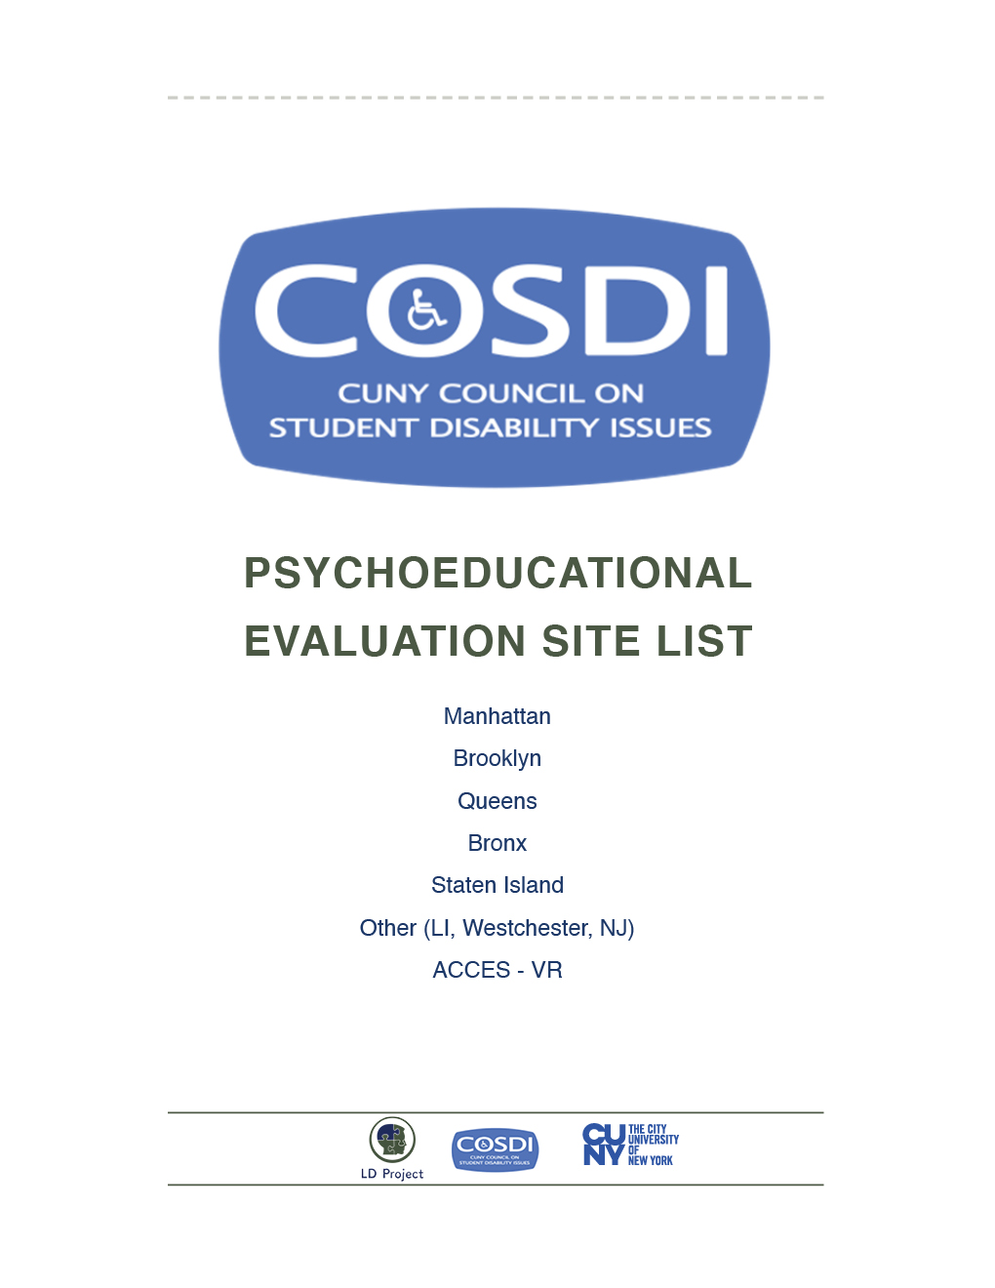

MANHATTAN
City College – City of NY Psychological Center Accessible
Address: North Academic Building, (NAC) 8/101
160 Convent Avenue, New York, NY 10031
Website: https://www.thepsychologicalcenter.org/
Phone: 212/650-6602
Contact: Michelle or Nicoleta (Clinic Administrator) 212/650-6602 or 212/650-5669
Cost: $300-$1,000 - Proof of income required
Payment plans as low as $5 per month
Insurance: Not accepted
Language: English, Spanish
Appointment: Can take 2-4 months for first appointment
Intakes are scheduled for 12pm on Wednesdays
Evaluation Report: 8 weeks
Comprehensive Consultation Psychological Services Accessible
Address: 180 East 79th Street, Suite 1C, NY, NY 10075
Website: http://comprehendthemind.com/
Phone: 718/441/0166 / 646/678-5977
Contact: Dr. Hafeez
Cost: CUNY Student Rate - $900/ CUNY ID required – verify when making appointment
Insurance:
In Network Cigna, Blue Cross/Blue Shield, Oxford, United Healthcare, Magnacare, Straight GHI and EBC
Language: English, Haitian Creole, Hindi/Urdu
Appointment: 2- 3 weeks
Evaluation Report: 6 weeks
Sachs Center Accessible
Address: 235 West 76th Street, Suite 1B, NY, NY 10023
Website: https://sachscenter.com/
Phone: 646/807-8900
Contact: Dr. George Sachs
Cost: $1,000 - $1,500
Insurance: Not accepted
Language: English
Appointment: No wait time
Evaluation Report: 3 weeks

Adelphi University Center for Psychological Services Manhattan Center Accessible
Address: 75 Varick Street, NY, NY 10013
Phone: 516-877-4820
Contact: Maria Etwaroo
Cost: $475 - $950 (Sliding Scale)
Insurance: Not accepted
Language: English, Spanish
Appointment: 2 months to schedule an appointment.
Evaluation Report: 6-8 weeks

Beth Israel Medical Center Mirken Department of Neurology —
Phillips Ambulatory Care Center Accessible
Address: 10 Union Square East, Suite 5H, New York, NY 10003
Phone: 212/844-8483
Contact: Dr. Christina Palmese
Cost: $4,000
Insurance: Not accepted
Language: English
Appointment: up to one week
Evaluation Report: 2 weeks
Albert Ellis Institute Accessible
Address: 145 East 32nd Street, 9th Floor, (Btw 3rd and Lex), NY, NY 10016
Phone: 212/535-0822
Contact: Dr. Michael Hickey
Cost: CUNY Student Rate - $700
Insurance: Not accepted
Language: English
Appointment: No Wait
Evaluation Report: 4 weeks
Childs Best Accessible
Address: 109 East 38th Street, Suite 2A, New York, NY 10016
Phone: 646/912/9074 / 646/859-6138
Contact: Dawn Learsy, MD, FAAP
Cost: Evaluations start at $2,500 – Payment plans up to one year
Insurance: Not Accepted
Language: English
Appointment: No wait period for first appointment
Center for Cognitive Assessment Accessible
Address: 240 Central Park South, Suite 2B, New York, NY, 10019
Phone: 212/342-1589
Contact: Andrea Reilly
Cost: $1,950-$2,950
Insurance: Will work with out of network plans: Oxford, Etna, United Healthcare, Empire,
Blue Cross Blue Shield, and Cigna
Language: English, Spanish
Appointment: 2 weeks to schedule
Evaluation Report: 3 weeks

Pace University Accessible
Address: Dyson College of Arts and Sciences
The Thomas J. McShane Center for Psychological Services
156 William Street, 5th Floor, NY, NY 10038
Website: ps://www.pace.edu/dyson/centers/thomas-mcshane-center-for-psychological-services/about
Phone: 212/346-1730
Contact: Eliza Adler (Psychological Services Coordinator)
Cost: $900 (Sliding Scale (bring proof of income). First intake costs 50$. Payment plans available
Insurance: Not accepted
Language: English, Spanish
Appointment: 2-10 months for first appointment
Evaluation Report: 6 weeks
SUNY College of Optometry Accessible
Address: 33 West 42nd Street, NY, NY 10003
Phone: 212/938-4001 x4062
Contact: Irma – Extension
Cost: $2,080 Students may qualify for a reduction
Proof of income necessary
Insurance: Medicaid can cover everything except 420$ “reporting conference”
Language: English, Spanish
Appointment: Waitlist Varies
Evaluation Report: 3 weeks
Teachers College, Columbia University Dean Hope Center for Educational &
Psychological Services Accessible
Address: 525 West 120th Street NY, NY 10027
Phone: 212/678-3262 (Fax 212/678-8105)
Cost: $200 - 1,000 Sliding scale (based on fee adjustment form) & student rates apply. Proof of income required.
Insurance: Not accepted
Language: English, Spanish
Appointment: Takes 2-3 weeks. Best time to contact is the beginning of the semester. Summer appointments not available
Evaluation Report: 2 weeks but varies with every student
Website: Tc.edu/deanhope
Columbia University Medical Center – Psychiatry Columbia Doctors Accessible
Address: 51 West 51st Street, Suite 340, NY, NY 10019
Phone: 212/326-8441
Contact: Cora
Cost: $600 - Sliding scale - Proof of income required
Insurance: Aetna Commercial & Aetna Student, Cigna (NYU), United Health (Through Colombia)
Language: English, Interpreter services available for all languages
Appointment: Can take 3-4 months after application is completed
Evaluation Report: 3 weeks
Neuropsychological Consulting of New York Accessible
Address: 40 Exchange Place, 3rd Floor, TRS, New York, NY, 10005
Phone: 917/270/3019 / 212/332-0051
Contact: Dr. Sandra Hunt
Cost: $1,200-$1,600 Sliding scale - Proof of income required
Insurance: Not accepted
Language: English, Vietnamese (Spanish - additional fees apply)
Appointment: 2 weeks to schedule an appointment.
Evaluation Report: 1 weeks
Advanced Neuropsychology Services, Dr. Dave Layman Accessible
Address 1: 226 W 26th Street, Floor 8, New York, NY 10001
Phone: 917/599-7838
Contact: Dr. Dave Layman (President of the New York State Association of Neuropsychology)
Cost: 1,000 - $1,500 (20% CUNY student discount with ID)
Insurance: Not accepted
Language: English
Appointment: 2 – 6 Weeks
Evaluation Report: 2 weeks
Dr. Matther Oyer Accessible
Address: 30 Charton St. Suite 1, New York, 10014
Phone: (347)/735-9848
Cost: $1,750-$3,000
Insurance: Not accepted
Language: English
Appointment: No wait time
Evaluation Report: 3 weeks
Dr William H. Baun Accessible
Address: 40 W 86th St, New York, NY 10024
Phone: (646) 351-7321
Cost: $1,750-$3,000
Insurance: Not accepted
Language: English
Appointment: No wait time
Evaluation Report: 3 weeks

BROOKLYN
Dr. Danov Neuropsychologist P.C. Pediatric and Adult Neuropsychology Accessible
Address: 95-11 Shore Road, Suite C, Brooklyn, NY 11209
Phone: 718/667-5530
Contact: Dana
Cost: $3,500 (additional $200 consultation fee)
Insurance: Not Accepted
Language: English, Russian
Appointment: 1- 2 weeks
Evaluation Report: 1 week
Dr. Emily Bravo Accessible
Address: 26 Court Street, Suite 1409, Brooklyn, NY 11201
Phone: 347/269-4296
Cost: $3,500 - $5,000
Insurance: Not Accepted
Language: English
Appointment: 2 months
Evaluation Report: 4 weeks
Brooklyn Learning Center Accessible
Address: 142 Joralemon Street, Brooklyn, NY 11201, Suite 3E
Phone: 718/935-0400
Cost: $3,000 – $6,500
Insurance: Not Accepted
Language: English
Appointment: 2 weeks
Evaluation Report: 3 weeks
Sachs Center Accessible
Address: 20 Court Street, Brooklyn, NY
Website: https://sachscenter.com/
Phone: 646/807-8900
Contact: Dr. George Sachs
Cost: $1,000 - $1,500
Insurance: Not accepted
Language: English
Appointment: No wait time
Evaluation Report: 3 weeks

QUEENS
Comprehensive Consultation Psychological Services Accessible
Address: 84-60 123rd Street, Kew Gardens, Queens, NY 11415
Website: http://comprehendthemind.com/
Phone: 718/441-0166
Contact: Dr. Hafeez
Cost: CUNY Student Rate - $900/ CUNY ID required – verify when making appointment
Insurance: In Network Cigna, Blue Cross/Blue Shield, Oxford, United Healthcare, Magnacare,
Straight GHI and EBC
Language: Haitian Creole, Hindi/Urdu
Appointment: 2-3 weeks
Evaluation Report: 6 weeks

St. John’s University - Center for Psychological Services & Clinical Studies Accessible
Address: Seton Complex, 152-11 Union Turnpike, Flushing, NY 11367
Phone: 718/990-1900 (Fax 718/990-1586). (11am-9pm Mon-Thurs, 9am-6pm Fri, 9am-1pm Sat)
Contact: Austin- Front Desk Manager
Cost: $400 Flat rate for students. Sliding Scale/Proof of income required
Insurance: Not accepted
Language: English, Spanish
Appointment: 1-2 weeks. Available services are reduced during the summer operations.
Evaluation Report: 2-3 months
Dr. Martin Friedmutter Accessible
Address: 36-35 Bell Boulevard, Room 203, Bayside New York 11361
Phone: 347-323-5331
Contact: Dr Friedmutter
Cost: Dependent of insurance coverage (Special CUNY rates are available)
Insurance: All insurances accepted
Language: English
Appointment: no wait
Evaluation Report:2-3 weeks

BRONX
Fisher Landau Center for the Treatment of Learning Disabilities (Albert Einstein) Accessible
Address: 1225 Morris Park Avenue, Bronx, NY 104661
Phone: 718/430-3906
Contact: Roberto Rodriguez (Administrative Coordinator)
Cost: Sliding Scale ranges from $15.00 – 250$
Insurance: Medicaid
Language: English
Appointment: 3-5 months (varies by how busy they are). Available services are reduced during the summer.
Evaluation Report: 8 weeks
The Max & Celia Parnes Family Psychological & Yeashiva University. PsychoEducational Services Clinic Accessible
Address: 1165 Morris Park Avenue, Russo Building, Bronx, NY 10461
Phone: 646/592/4399
Contact: Maggie & Carley (Assessment Coordinators)
Cost: Sliding Scale (varies)
Insurance: Not accepted
Language: English
Appointment: Intakes for evaluations are done in January and August
additional: Low cost therapy sessions, individual family couple, in psychodynamic cognitive behavioral available 718/430-3852
Evaluation Report: 8 weeks

Staten Island
Neuropsychological Consulting of New York
Facility is NOT Accessible
Address: 172 Raven Hurst Avenue, Staten Island, NY 10306
Phone: 917/270-3019
Contact: Dr. Sandra Hunt
Cost: $1,200-$1,600 (Sliding scale based on income. Proof of income required)
Insurance: Not Accepted
Language: English, Spanish (additional fees apply)
Appointment: 2 weeks to schedule an appointment
Evaluation Report: 2 weeks
Brain Academy – 4 locations – NYC, Brooklyn,
Queens, SI Accessible
Location #1: 139 Fulton Street, Suite 215, NY, NY 10039
Location #2: 95-11 Shore Road, Suite C, Brooklyn, NY 11209
Location #3: 76-13 113 Street, Suite 1F, Forest Hills, NY 11375
Location #4: 65 Kelvin Avenue, Staten Island, NY 10306
Phone: 1/877/556/9888 / 646/355/3395
Cost: $3,500 (consultation $200)
Insurance: Not Accepted
Language: English, Russian
Appointment: 1 week to schedule
Evaluation Report: 1 week

Long Island/New Jersey/Rochester
Adelphi University Center for Psychological Services – Long Island Accessible
Address: 1 South Avenue, Garden City, NY 11530
Phone: 516/877-4820
Contact: Maria Etwaroo
Cost: $475 - $950
Insurance: Not accepted
Language: English, Spanish
Appointment: 2 months to schedule an appointment.
Evaluation Report: 6 weeks
Hofstra University Saltzman Community Service Center Long Island Accessible
Address: 131 Hofstra University, Hempstead, NY 11549
Phone: 516/463-5660 or 516/463-6535
Contact: Joan Brady (Administrative Assistant)
Cost: $750
Insurance: Not accepted
Language: English
Appointment: 1 month
Evaluation Report: 1 month
Long Island University CW Post Campus Long Island Accessible
Address: 720 Northern Blvd, Lodge A, Brookville, NY 11548
Phone: 516/299-3211
Contact: Dr. Pando
Cost: $650 Maximum. Proof of income required. $100 payment upfront.
Insurance: Not accepted
Language: English
Appointment: 2 weeks to schedule an appointment.
Evaluation Report: 8 weeks
Neuropsychological Services of Westchester Westchester Accessible
Address: 34 South Broadway, White Plains, NY 10601
Phone: 914/949-4045 (or 4055)
Cost: $2,550
Insurance: Not accepted
Language: English
Appointment: 4 weeks
Evaluation Report: 8 weeks
Dr. Baer Westchester Facility is NOT Accessible
Address: 547 Saw Mill River Road, Suite 2C, Ardsley, NY 10502
Phone: 914/ 478-2861
Contact: Dr. Baer
Cost: $3,000-$5,000
Insurance: Not accepted
Language: English
Appointment: 2 weeks to schedule an appointment.
Evaluation Report: 4 weeks
Fairleigh Dickinson University Center for Psychological Services New Jersey Accessible
Address: 131 Temple Avenue, Hackensack, NJ, 07601
Phone: 201/692-2645 ext.1 OR ext. 224
Cost: $550-$650
Insurance: Not accepted
Language: English
Appointment: 2 weeks
Evaluation Report: 8 weeks

Rutgers Psychological Clinic – Graduate School of Applied & Professional Psychology New Jersey Accessible
Address: 152 Frelinghuysen Road, Piscataway, NJ 08854
Phone: 848/445-6111
Contact: Clinic Coordinator
Cost: $750
Insurance: Not accepted
Language: English, Spanish
Appointment: 4 weeks
Evaluation Report: 8 weeks

ACCES-VR
all offices are Accessible
Bronx District Office
Address: 1215 Zerega Avenue, Bronx, NY 10462
Phone: 718/931-3500
Fax: 718/931-4299
Cost: Free Services
Brooklyn District Office
Address: 55 Hanson Place, 2nd Floor, Brooklyn, NY 11217
Phone: 718/722-6700
Fax: 718/722-6714
Cost: Free Services
Manhattan District Office
Address: 116 West 32nd Street, 6th Fl, NY NY 10001
Phone: 212/630-2300 OR 212/630-2302
Fax: 212/630-2365
Cost: Free Services

Harlem Satellite Office
Address:
Adam Clayton Powell Jr. State Office Building
163 West 125th Street, 7th Floor, Room 713, NY, NY 10027
Phone: 212/961-4420
Fax: 212/961-4423
Cost: Free Services
Queens District Office
Address: 11-15 47th Avenue, LIC, NY 11101
Phone: 347-510/3100
Fax: 718/784-3702
Cost: Free Services
Staten Island Satellite Office
Address: 2071 Clove Road, Suite 302, Staten Island, NY 10304
Phone: 718/816-4800
Fax: 718/448-4843
Cost: Free Services

Long Island District Office
Address: 250 Veterans Highway, Room 3A-12, Hauppauge, NY 11788
Phone: 631/952-6357
Fax: 631/952-5826
Cost: Free Services
White Plains District Office
Address: 75 South Broadway, Suite 200, White Plains, NY 10601
Phone: 914/946-1313
Fax: 914/946-1726
Cost: Free Services
Westchester & Lower Hudson Services
Address: 75 Riverdale Avenue, Room 109, Yonkers, NY 10701
Phone: 914/946-1313
Cost: Free Services

