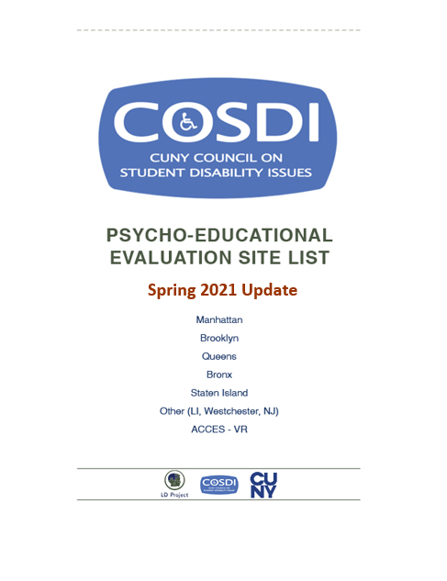

Long Island University CW Post Campus Long Island Accessible
Address: 720 Northern Blvd, Lodge A, Brookville, NY 11548
Phone: 516-299-3211
Contact: Dr. Pando
Cost: $650 Maximum (sliding scale based on income). $100 upfront payment required.
Insurance: Not accepted
Language: English
Appointment: Leave voicemail name and details. Will follow up to schedule. Up to 2 month wait for an appointment. Currently filling evaluations slots for the Spring and Summer.
Evaluation Report:8 weeks
DETAILS: Fully remote services available on a sliding scale

Comprehensive Consultation Psychological Services Accessible
Address1 : 180 East 79th Street, Suite 1C, NY, NY 10075
Address2 : 84-60 123rd Street, Kew Gardens, Queens, NY 11415
Website: http://comprehendthemind.com/
Phone: 718-441-0166 / 646-678-5977
Contact: Dr. Hafeez
Cost: CUNY Student Rate - $950/ CUNY ID required – verify when making appointment
Insurance: In Network Cigna, Blue Cross/Blue Shield, Oxford, United Healthcare, Magnacare, Straight GHI and EBC
Language: English, Haitian Creole, Hindi/Urdu
Appointment: 2- 3 weeks
Evaluation Report: 6 weeks
DETAILS: Open and following full COVID protocols; daily patient and employee checks, operating at 50-65% capacity, and preforming some elements of assessments via phone

Fisher Landau Center for the Treatment of Learning Disabilities (Albert Einstein) Accessible
Address: 1225 Morris Park Avenue, Bronx, NY 104661
Phone: 718-430-3906
Contact: Roberto Rodriguez (Administrative Coordinator)
Cost: Sliding Scale ranges from $15.00 – 250$
Insurance: Medicaid
Language: English
Appointment: 3-5 months (varies by how busy they are). Available services are reduced during the summer.
Evaluation Report: 8 weeks
DETAILS: Accepting referrals – wait time for appointment may be 3 months

City College – City of NY Psychological Center Accessible
Address: North Academic Building, (NAC) 8/101
160 Convent Avenue, New York, NY 10031
Website: https://www.thepsychologicalcenter.org/
Phone: 212-650-6602
Contact: Michelle or Nicoleta (Clinic Administrator) 212-650-6602 or 212-650-5669
Cost: $300-$1,000 - Proof of income required
Payment plans as low as $5 per month
Insurance: Not accepted
Language: English, Spanish
Appointment: Can take 2-4 months for first appointment. Intakes are typically scheduled towards the beginning of the term.
Evaluation Report: 8 weeks

Pace University Accessible
Address: Dyson College of Arts and Sciences
The Thomas J. McShane Center for Psychological Services
156 William Street, 5th Floor, NY, NY 10038
Website: www.pace.edu/dyson/centers/thomas-mcshane-center-for-psychological-services/about
Phone: 212-346-1730
Contact: Eliza Adler (Psychological Services Coordinator)
Cost: $900 - $4,000 (Sliding Scale (bring proof of income). First intake costs 50$. Payment plans available
Insurance: Not accepted
Language: English, Spanish
Appointment: 1-4 months for first appointment
Evaluation Report: 6 weeks
DETAILS: Reopening and accepting patients starting in May. First appointments will be during Summer and Fall 2021.

Teachers College, Columbia University Dean Hope Center for Educational &
Psychological Services Accessible
Address: 525 West 120th Street NY, NY 10027
Phone: 212-678-3262 (Fax 212-678-8105)
Cost: $200 - 1,000 Sliding scale (based on fee adjustment form) & student rates apply. Proof of income required.
Insurance: Private insurance not accepted. Can provide support processing pre-approvals through Medicaid insurance.

Insurance: Not accepted
Language: English, Spanish
Appointment: Takes 2-3 weeks. Best time to contact is the beginning of the semester. Summer appointments not available
Evaluation Report: 2 weeks but varies with every student
Website: https://www.tc.columbia.edu/deanhope/
DETAILS: Virtual only

Albert Ellis Institute Accessible
Address: 145 East 32nd Street, 9th Floor, (Btw 3rd and Lex), NY, NY 10016
Phone: 212-535-0822
Contact: Dr. Michael Hickey
Cost: CUNY Student Rate - $2,000
Insurance: Not accepted
Language: English
Appointment: Brief 1-2 week wait period during Fall and Spring semesters.
Evaluation Report: 4 weeks
DETAILS: Evaluations are performed in person. COVID Protocols in place.

Brooklyn Learning Center Accessible
Address: 142 Joralemon Street, Brooklyn, NY 11201, Suite 3E
Phone: 718-935-0400
Contact: Tanya
Cost: $3,000 – $6,500 (Sliding scale rates available)
Insurance: Not Accepted
Language: English
Appointment: 1-2 months
Evaluation Report: 3 weeks
DETAILS: Conducting 2/3rds of evaluations remotely

Madison Park Psychological Services Accessible
Address: 51 E 25th St, 5th Fl, New York, NY 10010
Phone: 212-506-5935
Contact: Shana Grover, Ph.D.
Cost: $3,000
Insurance: Not accepted
Language: English
Appointment: up to one week
Evaluation Report: 2 weeks - 1 month
Details: Some portions of evaluations are done in person as of July using masks, gloves and temperature checks.

NYU Langone Accessible
Address: 550 1st Avenue, New York, NY 10016
Website: https://nyulangone.org/locations/child-study-center
Phone: 646-765-4958
Cost: $3,650-6,500
Insurance: Not accepted
Language: English
Appointment: 1-2 weeks
Evaluation Report: 4-6 weeks
Details: Evaluations are hybrid - virtual and in-person

Center for Cognitive Assessment Accessible
Address: 240 Central Park South, Suite 2B, New York, NY, 10019
Phone: 212-342-1589
Contact: Andrea Reilly
Cost: $4,500-$6,500
Insurance: Will work with clients to determine coverage and out-of-pocket costs after MEDICADE and other provider (Oxford, Etna, United Healthcare, Empire, Blue Cross Blue Shield, and Cigna) coverage.
Language: English, Spanish
Appointment: 2 weeks to schedule
Evaluation Report: 3 weeks
DETAILS: Evaluations are hybrid - virtual and in-person

Beth Israel Medical Center Mirken Department of Neurology —
Phillips Ambulatory Care Center Accessible
Address: 10 Union Square East, Suite 5H, New York, NY 10003
Phone: 212/844-8483
Contact: Dr. Christina Palmese
Cost: $5,100
Insurance: Not accepted
Language: English
Appointment: up to one week
Evaluation Report: 2 weeks
DETAILS: Remote video services available

SUNY College of Optometry Accessible
Address: 33 West 42nd Street, NY, NY 10003
Phone: 212-938-4001 x4062
Contact: Irma – Extension
Cost: $3625 Students may qualify for a 25-75% reduction
Proof of income necessary
Insurance: Medicaid can cover everything except 420$ “reporting conference”
Language: English, Spanish
Appointment: Waitlist Varies
Evaluation Report: 3 weeks
DETAILS: May reopen in the Fall – Call for details.

Therapy Services (Tele-Health)

St. John’s University - Center for Psychological Services & Clinical Studies Accessible
Address: Seton Complex, 152-11 Union Turnpike, Flushing, NY 11367
Phone: 718-990-1900 (Fax 718/990-1586). (11am-9pm Mon-Thurs, 9am-6pm Fri, 9am-1pm Sat)
Contact: Austin- Front Desk Manager
Cost: Sliding Scale/Proof of income required
Insurance: Not accepted
Language: English, Spanish
DETAILS: Not providing Psycho-Education Evaluations- Psycho-Therapy services only

Hofstra University Saltzman Community Service Center Long Island Accessible
Address: 131 Hofstra University, Hempstead, NY 11549
Phone: 516-463-5660 or 516-463-6535
Contact: Joan Brady (Administrative Assistant)
Cost: Sliding Scale/Proof of income required
Insurance: Not accepted
Language: English
DETAILS: Not providing Psycho-Education Evaluations- Therapy services only

Fordham Community Mental Health Clinic
Accessible
Address: 557 East Fordham Road, 4th Floor, Bronx, NY 10458
Phone: 718-817-0590
Contact: Michelle Leon
Cost: Low cost and sliding scale rates.
Insurance: Not accepted
Language: English
Evaluation Report: 8 weeks
DETAILS: Not providing Psycho-Education Evaluations- Therapy services only. Leave a message for a call back in 1 business day.

