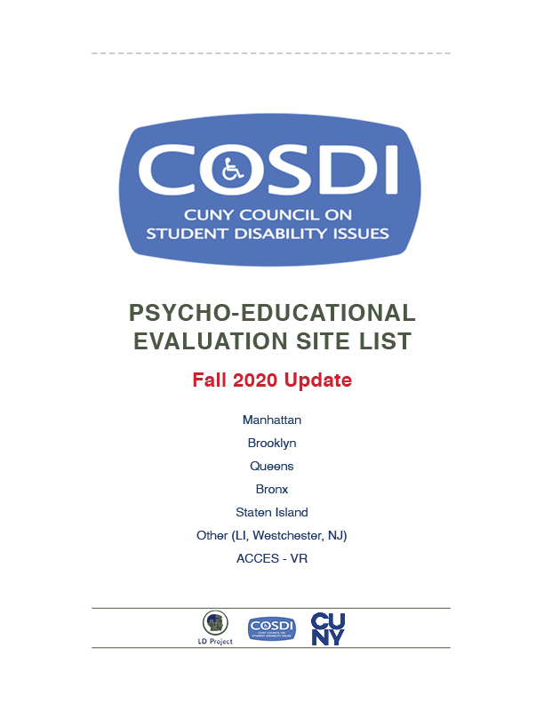

Long Island University CW Post Campus Long Island Accessible
Address: 720 Northern Blvd, Lodge A, Brookville, NY 11548
Phone: 516/299-3211
Contact: Dr. Pando
Cost: $650 Maximum (sliding scale based on income). $100 upfront payment required.
Insurance: Not accepted
Language: English
Appointment: 2 weeks to schedule an appointment.
Evaluation Report: 8 weeks
DETAILS: Fully remote services available on a sliding scale

Comprehensive Consultation Psychological Services Accessible
Address1 : 180 East 79th Street, Suite 1C, NY, NY 10075
Address2 : 84-60 123rd Street, Kew Gardens, Queens, NY 11415
Website: http://comprehendthemind.com/
Phone: 718/441/0166 / 646/678-5977
Contact: Dr. Hafeez
Cost: CUNY Student Rate - $900/ CUNY ID required – verify when making appointment
Insurance: In Network Cigna, Blue Cross/Blue Shield, Oxford, United Healthcare, Magnacare, Straight GHI and EBC
Language: English, Haitian Creole, Hindi/Urdu
Appointment: 2- 3 weeks
Evaluation Report: 6 weeks
DETAILS: Open and following full COVID protocols; daily patient and employee checks, operating at 50-65% capacity, and preforming some elements of assessments via phone
Fisher Landau Center for the Treatment of Learning Disabilities (Albert Einstein) Accessible
Address: 1225 Morris Park Avenue, Bronx, NY 104661
Phone: 718/430-3906
Contact: Roberto Rodriguez (Administrative Coordinator)
Cost: Sliding Scale ranges from $15.00 – 250$
Insurance: Medicaid
Language: English
Appointment: 3-5 months (varies by how busy they are). Available services are reduced during the summer.
Evaluation Report: 8 weeks
DETAILS: Accepting referrals – wait time for appointment may be 3 months

Brooklyn Learning Center Accessible
Address: 142 Joralemon Street, Brooklyn, NY 11201, Suite 3E
Phone: 718/935-0400
Contact: Tanya
Cost: $3,000 – $6,500 (Sliding scale rates available)
Insurance: Not Accepted
Language: English
Appointment: 2 weeks
Evaluation Report: 3 weeks
DETAILS: Conducting 2/3rds of evaluation remotely

Madison Park Psychological Services Accessible
Address: 51 E 25th St, 5th Fl, New York, NY 10010
Phone: 212-506-5935
Contact: Shana Grover, Ph.D.
Cost: $3,000
Insurance: Not accepted
Language: English
Appointment: up to one week
Evaluation Report: 2 weeks - 1 month
Details: Some portions of evaluations are done in person as of July using masks, gloves and temperature checks.
NYU Langone Accessible
Address: 550 1st Avenue, New York, NY 10016
Website: https://nyulangone.org/locations/child-study-center
Phone: 646/765-4958
Cost: $3,650-6,500
Insurance: Not accepted
Language: English
Appointment: 1-2 weeks
Evaluation Report: 4-6 weeks
Details: Evaluations are hybrid - virtual and in-person
Center for Cognitive Assessment Accessible
Address: 240 Central Park South, Suite 2B, New York, NY, 10019
Phone: 212/342-1589
Contact: Andrea Reilly
Cost: $4,500-$6,500
Insurance: Will work with out of network plans: Oxford, Etna, United Healthcare, Empire,
Blue Cross Blue Shield, and Cigna
Language: English, Spanish
Appointment: 2 weeks to schedule
Evaluation Report: 3 weeks
DETAILS: Evaluations are hybrid - virtual and in-person
Beth Israel Medical Center Mirken Department of Neurology —
Phillips Ambulatory Care Center Accessible
Address: 10 Union Square East, Suite 5H, New York, NY 10003
Phone: 212/844-8483
Contact: Dr. Christina Palmese
Cost: $5,100
Insurance: Not accepted
Language: English
Appointment: up to one week
Evaluation Report: 2 weeks
DETAILS: Remote video services available
SUNY College of Optometry Accessible
Address: 33 West 42nd Street, NY, NY 10003
Phone: 212/938-4001 x4062
Contact: Irma – Extension
Cost: $2,080 Students may qualify for a reduction
Proof of income necessary
Insurance: Medicaid can cover everything except 420$ “reporting conference”
Language: English, Spanish
Appointment: Waitlist Varies
Evaluation Report: 3 weeks
DETAILS: May reopen in the Fall – Call for details.

Therapy Services (Tele-Health)
St. John’s University - Center for Psychological Services & Clinical Studies Accessible
Address: Seton Complex, 152-11 Union Turnpike, Flushing, NY 11367
Phone: 718/990-1900 (Fax 718/990-1586). (11am-9pm Mon-Thurs, 9am-6pm Fri, 9am-1pm Sat)
Contact: Austin- Front Desk Manager
Cost: Sliding Scale/Proof of income required
Insurance: Not accepted
Language: English, Spanish
DETAILS: Not providing Psycho-Education Evaluations- Psycho-Therapy services only

Hofstra University Saltzman Community Service Center Long Island Accessible
Address: 131 Hofstra University, Hempstead, NY 11549
Phone: 516/463-5660 or 516/463-6535
Contact: Joan Brady (Administrative Assistant)
Cost: Sliding Scale/Proof of income required
Insurance: Not accepted
Language: English
DETAILS: Not providing Psycho-Education Evaluations- Therapy services only

Fordham Community Mental Health Clinic
Accessible
Address: 557 East Fordham Road, 4th Floor, Bronx, NY 10458
Phone: 718/817-0590
Contact: Michelle Leon
Cost: Low cost and sliding scale rates.
Insurance: Not accepted
Language: English
Evaluation Report: 8 weeks
DETAILS: Not providing Psycho-Education Evaluations- Therapy services only. Leave a message for a call back in 1 business day.

