Authorizing JAWS Client
After the initial installation of JAWS on a client, you will need to configure the client to see the license server.
- On the client machine go to Start Control Panel and open System Properties
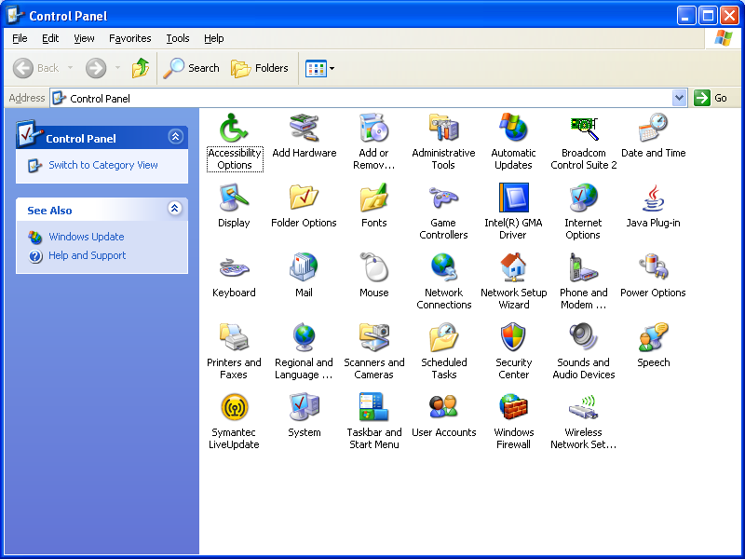
System
Properties
- In the System Properties interface will appear. In the Advanced Tab click the Environment Variables Button.
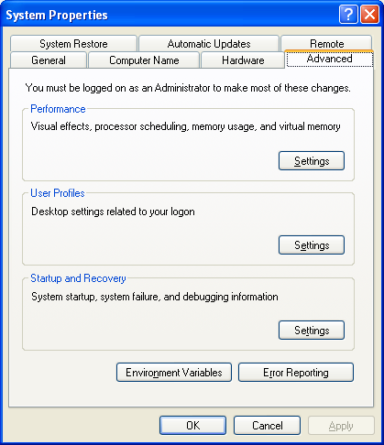
Advanced Tab
Environment Variables

- When the Environment Variables Interface opens, click on the "New" button under System Variables.
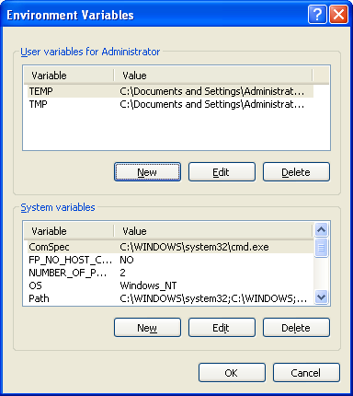
New
System Variables

- The New System Variable interface will appear. 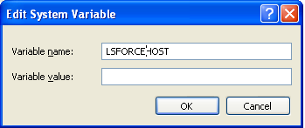
OK
Variable value
Variable name
ALL CAPITAL

*Contact CATS for this information
Variable Name:
Variable Value:

- Fill in the fields with the appropriate information for the license server you are trying to connect to. Then click “OK”

Variable Name: (All capital letters) is used to access an external license server.

Variable Value: Value should be the IP address
Of the license server housing your JAWS license
Contact CATS for your IP address.

