JAWS Client Installation
- After inserting the CD into the CD-ROM drive, Windows will automatically open a new window.
*Alternate instructions: If Windows does not automatically run, go to “My Computer” and locate the CD-ROM Drive 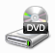 and double click on it.
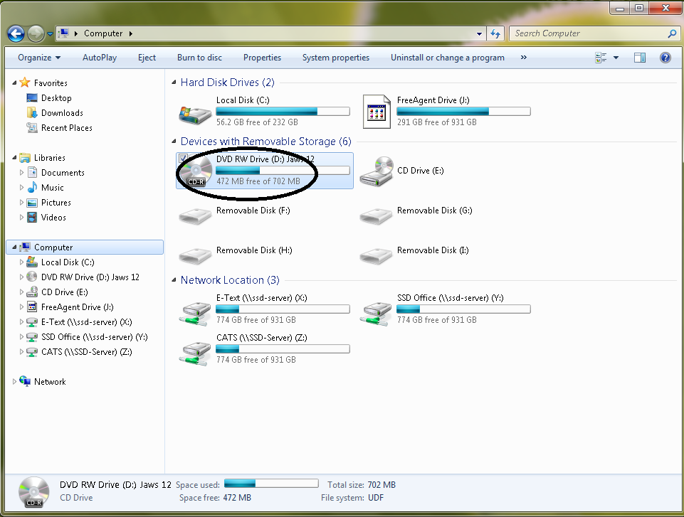

- There will be two files located in the open window, select and double-click the appropriate version (32-bit or 64-bit) for your system.
* The 32-bit version would be the most common version used.
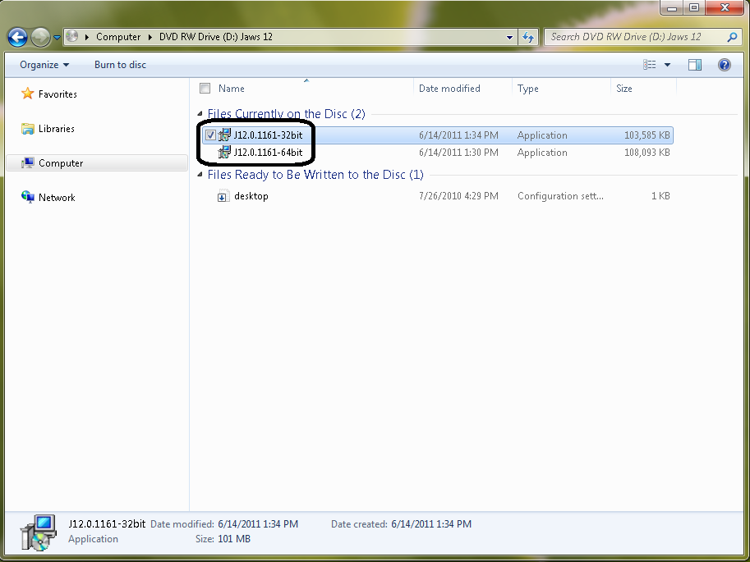

- Click on “Next” and the following status box will show. (Look below)
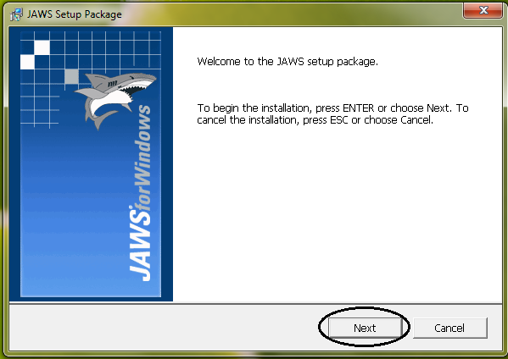

- Click on “OK” to reboot the system
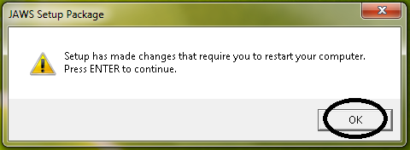

- After reboot the JAWS 12 installation will continue and a Status box will show.
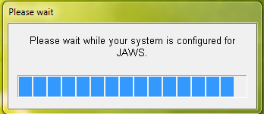

- Click on “Next”.
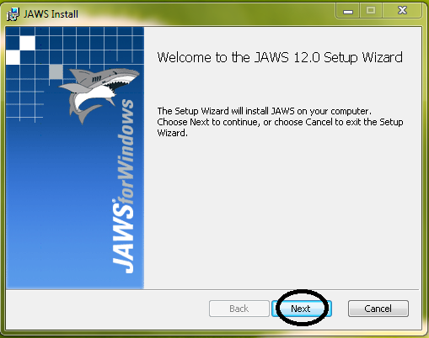

- Check off the box for the License Agreement and click on “Next”.
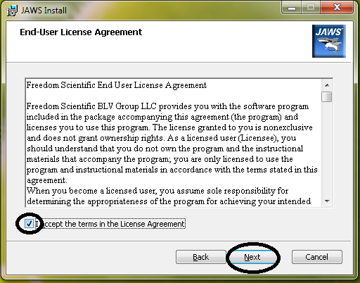

- Click on “Typical”.
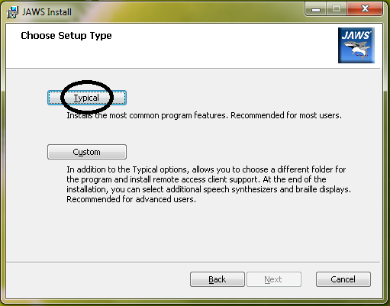

- Click on “Install” and the installation will begin.
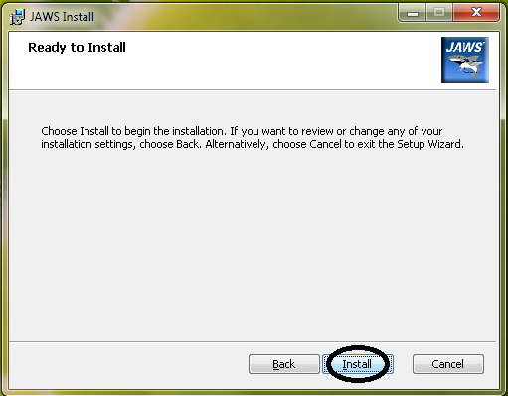
- Click on “Finish” to complete the installation.
