Kurzweil 3000 Network Installation Guide for Windows
Make sure you have extracted the file after downloading. Then go into the file titled “InstallTemp_Kurzweil3000_(Version of the software)”. Click the Setup file and then you’ll received the following options.
- Click Install Web Licensing Software

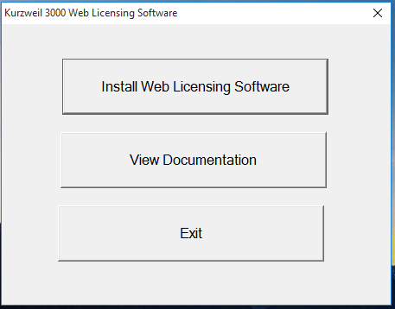
- Click Next
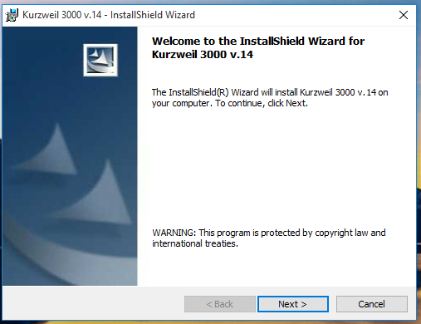

- Accept the licensing agreement
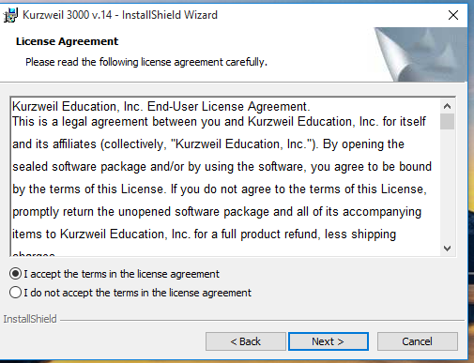

- For User Name, title it as “SSD” and for Organization type in “CATS”

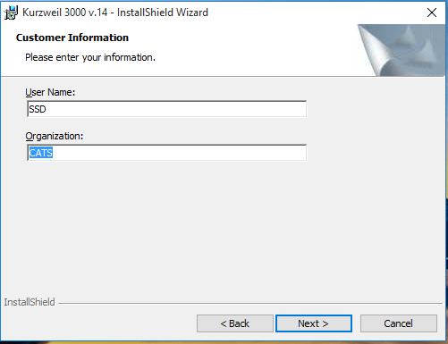

- Select complete
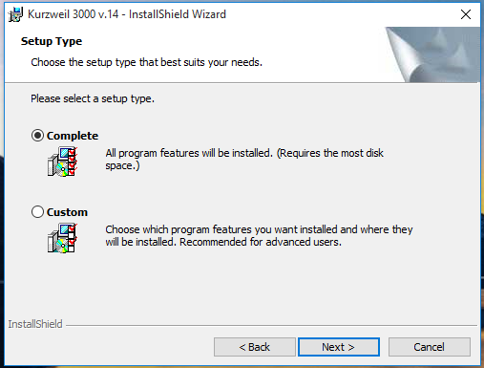

- Click Install
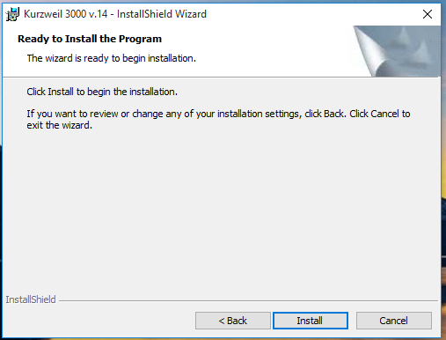

- Then after you get through the progress bar press Finish

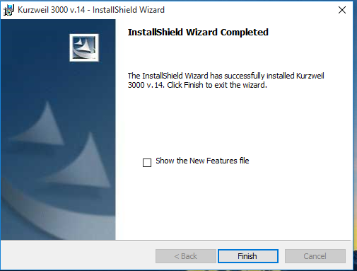

- Lastly, after the installation you’ll be asked to restart your machine and that’s it.

