K3000 Network Installation Guide for Mac

This is a guide will walk you through how to install Kurzweil 3000 on Mac. For your information this was performed on the version El Capitan.

- Below is the Web License window where you will find K3000 after launching the download k3000 file. You will be presented with this Windows below demonstrating 6 different items. Now launch the “Kurzweil 3000.pkg” file to begin.

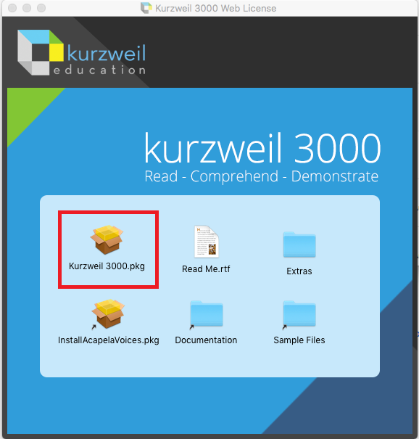

- The K3000 Installer window will appear asking you to click Continue. You will be asked to accept Terms and installation options. Note, you might be asked for the Administrator password if you don’t have those privileges already.
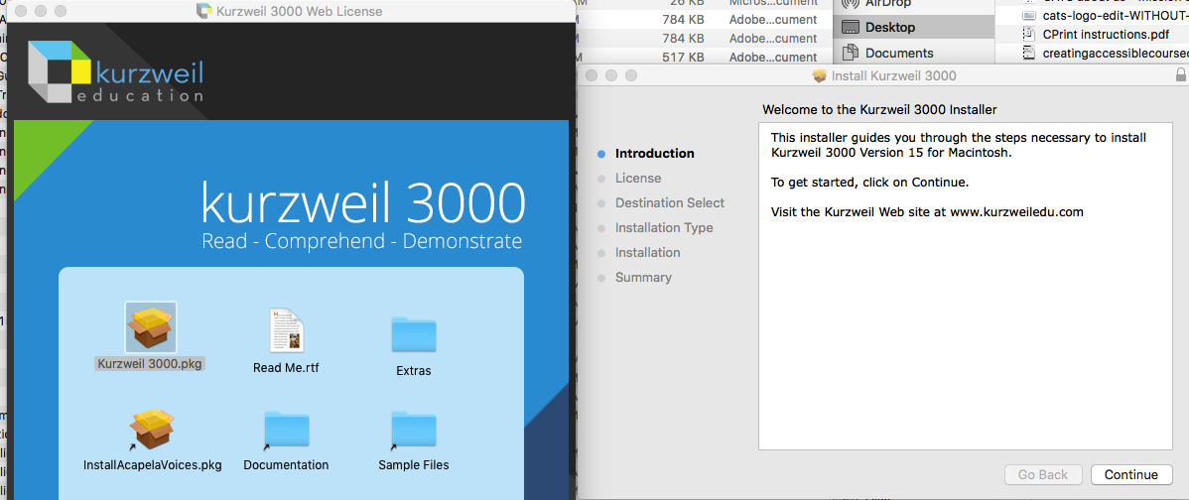

- Once done you’ll be presented with a green check mark telling you it has been successfully installed. You’re done and now can search for the software in the LaunchPad.

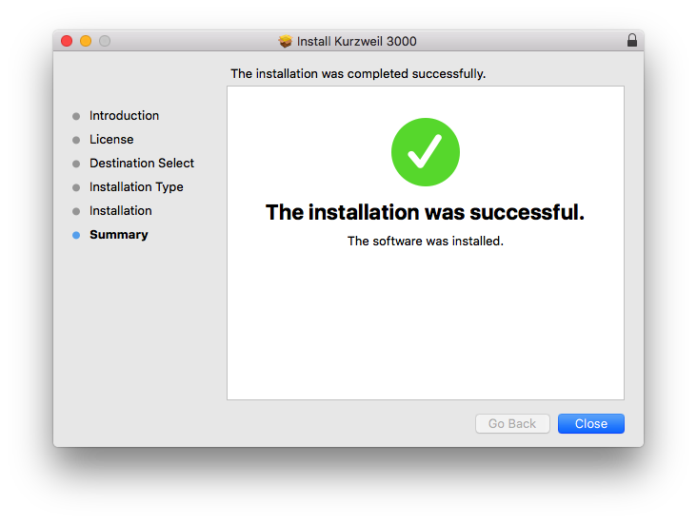

Optional: You can install other Text To Speech Voices for K3000 by selecting the “InstallAcapelaVoices.pkg” file in the Web License window. You go through the same installer as before. You will need Admin privileges if you don’t have them already

