Free or Low Cost Assistive Technology for Everyone
These Assistive Technology tools can be used by anyone, anywhere! All programs, Apps, and software on this list are free or cost.

Reading & Literacy Support:

Natural Reader
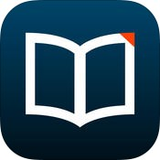 | - Text-to-Speech software which converts Microsoft Word, Webpages, PDFs, and Email into spoken text  - Customize reading voice and speed for your readings  - Floating toolbar to read text in other applications  - Online Text-to-Speech program with options to input text from various sources on your computer  - More Information: http://www.naturalreaders.com/
Cost: Free | Compatibility: Windows; Mac OS; Online Resource

Voice Dream Reader
- Text-to-speech app to read books with the ability to customize your screen for preferred reading options
- Read by listening to the text, visually or both at the same time
- Supports PDF, Word Docs, EPUB, DAISY, eBooks, Web pages and more with the ability to integrate your Book share books or books in Dropbox, Evernote, Pocket, Gutenberg and more
- Includes multiple language options along with various fonts, including Open Dyslexic font, and voices, including the option to purchase additional voices
- Highlight information in the reading and export it to other programs and apps
- More Information: http://www.voicedream.com/features/
Cost: $9.99; Voice Dream Reader Lite –  Free | Compatibility: iOS: iPad, iPhone, iPod touch; Android

Beeline Reader
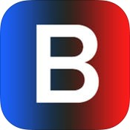 | - Polychrome color text reader with Open Dyslexic Font  - Read PDF files, webpages and convert eBooks to PDF files to be read with this program  - Polychrome color text helps eyes to track lines of text for easier, faster reading by eliminating “line transition errors.”  - Various monochrome color schemes for personalized use  - More Information: http://www.beelinereader.com/
Cost: $1.99 – iOS app;  browser extensions free | Compatibility: Browser Extension: Chrome & Firefox; iOS: iPad, iPhone; Desktop

ReadMe!
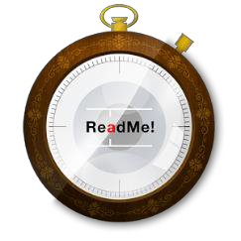 | - Read PDF and ePUB files on your tablet when you upload them to your bookshelf  - Spritz Reader is integrated into it – a tool for speed reading showing one word at a time to the reader  - Beeline Reader – polychromatic text color reader integrated into pay option of app  - More Information: https://www.readmei.com/
Cost: Free with Spritz Reader but Beeline Reader has additional monthly ($0.99), yearly ($4.99) or lifetime  membership options | Compatibility: iOS: iPad, iPhone, iPod Touch; Android

Mercury Reader
- Remove clutter from webpages for easier reading
- Customize the size of the test, the font, and if it’s a light or dark themed background
- Send the reading to Kindle for reading on that device
- More Information: https://mercury.postlight.com/reader/
Cost: Free | Compatibility: Chrome Extension

Rewordify
- Rewordify replaces higher-level vocabulary with words that are easier to understand
- Help build understanding within readings and builds vocabulary
- Difficult words are replaced and highlighted
- Click on the words that were replaced to see the original word in the text
- More Information: http://rewordify.com/
Cost: Free | Compatibility: Online Resource

Balabolka
- Text-to-Speech program using the voices installed on your computer
- Save online text as mP3, mP4, WAV, OGG or WMA file for portable or later listening
- Reads documents from the clipboard or file types such as DOC, EPUB, HTML, PDF, RTF, and more
- Customize the background color, font size, and reading options including pitch and rate
- More Information: http://www.cross-plus-a.com/balabolka.htm
Cost: Free | Compatibility: Windows

Ghost Reader
- Text-to-Speech app for Mac computers
- Reads your text aloud with the ability to customize voices and modify the pronunciation of words so it sounds correct when reading
- Ability to zoom and highlight words
- Covert text to audio files for on-the-go listening
- Import text from a variety of formats including Text, Word, HTML, PDF & RTF
- More Information: http://www.convenienceware.com/ghostreader
Cost: $24.99 | Compatibility: Mac

Claro ScanPen
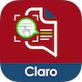 | - Listen to printed material on the spot  - Take a photo of your printed document, select text with your finger, and have it read back to you  - Compatible with Voiceover  - Multiple languages  - More Information: https://www.claro-apps.com/claro-scanpen/
Cost: $6.99 | Compatibility: iOS; Android

Claro PDF Pro
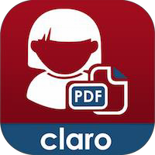 | - Listen to your PDFs read aloud using the built-in voices on iOS as well as 4 high quality voices  - Convert images to fully accessible PDF files that can be spoken, searched, copied, or highlighted  - Change the background color of document and invert the text colors  - Annotate and mark up your document using highlights, underlines, strike outs, notes, drawing, insert images, audio, video and more  - More Information: https://www.claro-apps.com/claropdf/
Cost: $6.99 | Compatibility: iOS; Android

Select and Speak (formerly SpeakIt!)
- Select the text you want read aloud in your browser
- Click on the SpeakIt! Icon and the text will be read out loud
- Can read text in more than 50 languages
- Ability to add new voices and change the speaking rate
- More Information: https://chrome.google.com/webstore/detail/select-and- speak-text-to/gfjopfpjmkcfgjpogepmdjmcnihfpokn?hl=en
Cost: $2.99/month | Compatibility: Chrome Extension

Spritz
- Test your reading speed using Spritz to find your optimum reading speed to use in partnership with Readsy
- Increase or decrease the test reading speed to find your balance of speed and comprehension
- Spritz custom interface called the Spritzlet, adjusts word position and red letter placement for increased focus, attention and comprehension
- Various website and apps have the Spritz Spritzlet embedded in it
- More Information: http://www.spritzinc.com/
Cost: $0.99 | Compatibility: Web; iOS; Android

Readsy
- Use Readsy to focus your eyes on one word at a time without having to move them while reading
- Upload a PDF, txt or copy and paste text into the website to have it read in their Readsy interact
- Use Readsys interface adjusts position of word for optimum viewing in your eyes and highlights one letter of each word in red to help focus your eyes
- Increase reading speed and comprehension using Readsy
- Use Spritz to test yourself to find optimum reading speed
- More Information: http://www.readsy.co/
Cost: Free | Compatibility: Online Resource

Read Mode
- Remove distractions from reading on the internet with this app
- Click the Chrome Extension for clean reading with black text on white background
- Ads and flash animations removed by the click of a button
- More Information: https://goo.gl/wY6nY
Cost: Free | Compatibility: Chrome Extension

VBookz PDF Reader
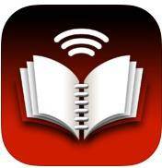 | - Read PDF files with this app  - Interactive cursor allows readers to follow along with text  - Use annotation tools such as highlighting, text, notes, and bookmarks to help support your reading  - Read books in text mode with the option for dyslexic Font  - Import PDFs using email, Dropbox, or through iTunes  - More Information: http://vbookz.com/
Cost: $14.99 | Compatibility: iOS: iPad, iPhone, iPod touch

Spreed
- Train yourself to increase your reading speed with Spreed
- Import online articles and have them read at double or triple the speed
- Spreed can train you to read between 200 and 400 words per minute
- More Information: https://goo.gl/uHKNHO
Cost: Free | Compatibility: Chrome Extension

Ivona MiniReader
- Use the Ivona Text-to-Speech Reader to read documents or webpages
- Using the either the Full or Mini toolbar interface, click the play button to have webpages, emails, documents, and online news sources read out loud
- More Information: http://www.ivona.com/us/mini-reader/
Cost: Free | Compatibility: Windows

spreeder
- Free online web application to help you read faster
- Copy and paste text from any source into the online application and spreed!
- Words will flash at a words per minute rate as you read along and increase your reading speed
- Ability to adjust words per minute speed, chunk size/number of words flashed, background color and more
- More Information: http://www.spreeder.com/
Cost: Free | Compatibility: Online Resource

Text2Speech.org
- Enter text from any source and have it read out loud by this online resource
- Ability to download file to an mp3 file
- Customize voice and speed
- 4000 character limit to text read
- More Information: http://www.text2speech.org/
Cost: Free | Compatibility: Online Resource

TextGrabber 6 Real Time OCR
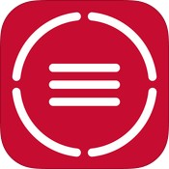 | - Using the camera of your device, capture text and translate it using OCR  - Easily extract text from books, magazines, newspapers, ads, etc.  - Use Voiceover (iPad only) to listen to your document in a text-to-speech format  - Captured text can be edited and/or copied to another source  - More Information: http://www.abbyy.com/textgrabber_ios/
Cost: Free | Compatibility: iOS: iPad, iPhone, iPod touch; Android

Capti Narrator
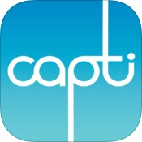 | - Convert documents and webpages into text-to-speech  - Upload documents from Dropbox, Google Drive, Clipboard, Instapaper, or Web Browser  - Listen to document immediately or save it to your playlist for future listening  - Adjust speech rate along with the choice of built in voices; additional voices for purchase  - More Information: https://www.captivoice.com/capti-site/
Cost: Free | Compatibility: iOS: iPad, iPhone, iPod touch; Windows and Mac Browser Extension

Prizmo
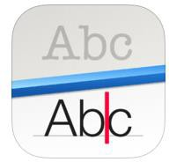 | - Take a picture and have immediate conversion into text with this OCR program for text-to-speech  - Ability to change the voice and interactive reading display with words highlighted as they are read  - 10 different languages built in with over 30 addition for download  - Ability to edit the OCR results to correct spelling errors or reorder text  - More Information: http://www.creaceed.com/prizmo/about
Cost: $49.99 | Compatibility: iOS: iPad, iPhone

Adobe Acrobat Reader
- Free PDF reader if PDF documents are readable PDFs
- Listen to readings instead of reading them yourself
- Tagged PDFs are read in order in structure tree, untagged are read in logical inferred reading order
- Tagged PDFs will read alternative text descriptions
- More Information: http://help.adobe.com/
Cost: Free | Compatibility: Windows; Mac OS

Bookshare
- Largest online library of accessible reading materials for people with print disabilities
- Accessible books, textbooks, newspapers and magazine are available
- Individuals with Print Disabilities can sign up for a membership
- Books available for download can be read on DAISY players, with Screen Readers, Refreshable Braille Displays, and other Assistive Technology Programs
- More Information: https://www.bookshare.org/
Cost: Free with Print  Disability | Compatibility: Online Resource

Go Read
- Download and listen to your Bookshare books on your Android device
- Read DAISY and EPUB books with voice navigated and text-to-speech
- Connects directly to online libraries, and Bookshare for quick download
- Optimized for visually-impaired readers but usable for anyone
- More Information: http://goread.org/
Cost: Free | Compatibility: Android

Read2Go Bookshare
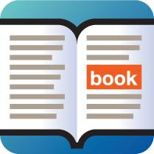 | - Browse over 190,000 books for have access all of your Bookshare books on your mobile device  - Easy use app to read text or turn on the text-to-speech mode  - Control the text layout of the page for easier visual reading including font size, color, background and reading options such as reading speed, and voice options  - Connect via Bluetooth to a braille display to read in Braille  - More Information: http://read2go.org/
Cost: $19.99 | Compatibility: iOS: iPad, iPhone, iPod touch

Cometdocs PDF Converter
- Create and convert PDF documents to Word, Excel, PowerPoint, Images, and other formats
- Use within Google Drive with the converted documents waiting for you there
- Use the web application, desktop app or app on your iOS device to convert documents too
- More Information: http://www.cometdocs.com/
Cost: Free | Compatibility: Windows; iPad, iPhone; Chrome Extension

Fokus
- Highlight only the text you want to read while Fokus dims and darkens the rest of your Chrome or Firefox window with an overlay
- Highlights the paragraph you’re reading with the ability to change the opacity of the background overlay
- Easy to install extension with the ability to turn the feature on or off
- More Information: https://chrome.google.com or https://addons.mozilla.org/
Cost: Free | Compatibility: Chrome and Firefox Add-On

CamScanner
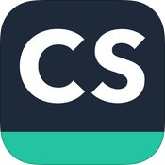 | - Use your camera phone to scan documents, notes, whiteboards, business cards or any other document  - Use the Optical Character Recognition (OCR) feature to convert images to readable text  - Add annotations to your scanned documents  - Sync documents across devices  - More Information: https://www.camscanner.net/
Cost: Free | Compatibility: iOS: iPad, iPhone; Android; Windows Phone 8

ER Browser
- Adapt and adjust webpages to your own reading preference settings
- Choose your font from options such as pen dyslexic
- Customize the background color of the webpage to decrease visual stress and improve reading ability
- Adjust font size and letter spacing
- Bookmark your favorite websites or search your stored history
- More Information: http://erbrowser.com/
Cost: $0.99 | Compatibility: iOS: iPad, iPhone; iPod touch

Writing:

Ginger Grammar Checker & Spell Checker
- Checks your spelling and grammar and fixes it according to the context of your text in Microsoft Word, Outlook, PowerPoint, Internet Explorer, Firefox, Safari, Chrome
- Suggests different and better ways to express your sentences (Premium)
- Provides training to improve your mistakes (Premium)
- Reads your text out loud (Premium)
- More Information: http://www.gingersoftware.com/
Cost: Free, Premium  $5.10-11.20/month | Compatibility: Windows; Mac; Android, iOS: iPod, iPhone, iPod touch; Chrome and Safari  Extension

Ghotit
- Online Contextual and phonetic spell checker along with grammar and punctuation checker
- Copy text into web page and program will check your grammar, spelling and punctuation
- More Information: http://www.ghotit.com/
Cost: $99.00 | Compatibility: Online Resource

Voice Dream Writer
- Make fewer mistakes, use the right words and organize your writing better with this app
- Text-to-speech and voice-to-text help you to proofread to avoid awkward sentences or grammatical mistakes
- Dictionary, Phonetic Spell Checker, and Word Finder help you use the correct words when writing
- Outline of paper allows for better structure and ease when restructuring your paper
- More Information: http://www.voicedream.com/writer/
Cost: $9.99 | Compatibility: iOS: iPad, iPhone, iPod touch

Grammarly
- Eliminate writing mistakes and contextual errors, spelling errors, and poor vocabulary usage
- Find the right word you are looking for with synonym suggestions
- Learn from your mistakes to avoid them in the future
- Grammarly works anywhere your Chrome browser in including emails, essays, social media posts and more
- More Information: https://www.grammarly.com/
Cost: Free | Compatibility: Chrome Extension

Co:Writer
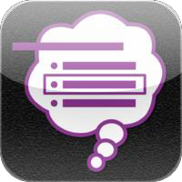 | - Word Prediction app that gives you suggestions of words as you type with the option of reading your word options out loud with a swipe of your finger  - Built-in text-to-speech reads back what you’ve typed  - Grammar and spelling support  - Export files to Dropbox, Google Drive, and other programs  - Create topic dictionaries from websites and Wikipedia links  - More Information: http://donjohnston.com/cowriterapp
Cost: $19.99 | Compatibility: iOS: iPad, iPhone; iPod touch

Typ-O HD
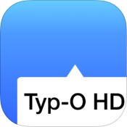 | - Word prediction with text-to-speech capability to hear the word options before you select them  - Ability to enter text on the screen using speech recognition  - Listen to your work with the text-to-speech feature  - Spell checker built in that frequently gets misspelled words right  - More Information: http://secondguessapps.com/typ-o-hd/
Cost: $14.99 | Compatibility: iOS: iPad, iPhone, iPod touch

Fleksy
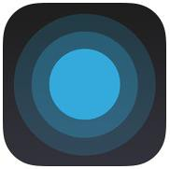 | - Increase your keyboard or text input system size to 114% the normal size increase ease of sight using this QWERTY keyboard  - State-of-the-art system powerful enough for individuals who are blind or low vision to use by not needing to look at the screen to type  - Powerful word prediction system and autocorrect system edits your text without the need to even see the keyboard  - More Information: http://fleksy.com/
Cost: $0.99 | Compatibility: iOS: iPad, iPhone, iPod touch; Android

Text Expander
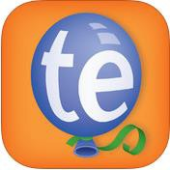 | - Type more with less effort using this custom keyboard shortcut app  - Create custom abbreviations called snippets of frequently used words and phrases for easy, quick entry into your documents  - Insert snippets by simply touching on them on your screen  - Use Dropbox to sync your snippets across devices  - More Information: http://smilesoftware.com/TextExpander/
Cost: $3.99 a month | Compatibility: iOS: iPad, iPhone, iPod touch

Notetaking:

Notability
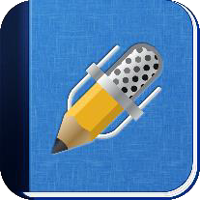 | - Write, type, or annotate using highlighters your notes using the all in one notetaking app  - Ability to take pictures and audio record with sound being linked to your notes  - Use Google Drive, Dropbox and Box to import, export and share documents such as PowerPoints and take notes direction on them  - Organize all your notes in one place  - More Information: http://www.gingerlabs.com/
Cost: $9.99 | Compatibility: Mac; iOS: iPad, iPhone, iPod touch

SoundNote
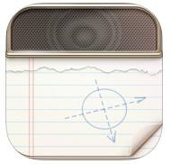 | - Type or write out your notes while the audio recording is synced to each word or pen stroke  - Tap on the word and then the play button to playback what was being said at that moment in the audio recording  - Share your audio recording and notes via email, Dropbox, or transfer directly to your computer  - More Information: http://soundnote.com/
Cost: $4.99 | Compatibility: Mac ; iOS: iPad

Sonocent Recorder
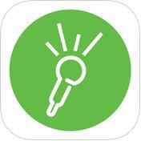 | - Record your notes on your portable device  - Highlight important parts of your recording and add notes  - Ability to add in photos or images into app notes  - Ability to draw notes into program, not just type  - Break up your recording and tag it to make it easier to find later  - Upload to the Sonocent Audio Notetaker Program on your computer  - More Information: http://www.sonocent.com/recorder
Cost: Free: Ability to Record; Price Pending: Unlimited Playback on  App | Compatibility: iOS: iPad, iPhone; iPod touch

AudioNote
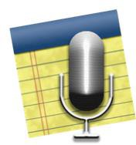 | - Synchronize your notes with the audio recording of your lecture  - Take hand-written  - Import lecture slides as the background to your notes  - More Information: http://luminantsoftware.com/iphone/audionote
Cost: Free – Lite; $4.99 | Compatibility: Windows; Mac; iOS: iPad; Android

Microsoft OneNote
- Take all your notes in OneNote by typing, writing with a touchscreen, importing pictures, video, web links and other resources
- Ability to record your lecture with this program
- Divide up your classes and work by notebook, section, and pages
- Using OneDrive online, share your OneNote document for others to work on and interact with
- Search your notes for the ability to easily find what you need
- More Information: http://office.microsoft.com/en-us/onenote/
Cost: Free | Compatibility: Windows, Mac OS, iOS: iPad, iPhone, Android, Windows Phone

WritePad
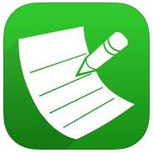 | - Take notes with your stylus or finger while handwriting recognition turns these notes into typed text  - Recognition adapts, adjusts, and learns your style of writing over time  - Built in spell check with custom dictionary, context analyzer, autocorrect, and Shorthand feature  - Synchronize documents with Evernote, Dropbox, iTunes, Google Docs, Email and more!  - More Information: http://www.phatware.com
Cost: $4.99 | Compatibility: iOS: iPad, iPhone; Android

AccessNote
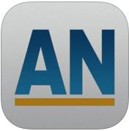 | - Notetaking tool for those who are Blind or Visually Impaired created by the American Foundation for the Blind  - App combines notetaking capabilities with the other accessibility features and functions of the iOS device  - Input notes with either QWERTY Keyboard, refreshable Braille Display  - More Information: http://goo.gl/bozjm7
Cost: Free | Compatibility: iOS: iPad, iPhone, iPod touch

Evernote
- A one-stop place to collect notes, files, web clippings, and images with the ability to access them on virtually any device
- Collect and find your information easily
- Great tool for researching, planning events and everyday organizational use
- Collaborate with others on projects using the sharing features
- More Information: http://evernote.com
Cost: Free | Compatibility: Windows; Mac; iOS: iPad, iPhone; iPod touch; Android; Windows Phone;  Blackberry; hp WebOS

Penultimate
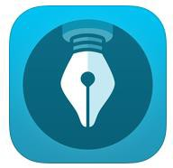 | - Write, sketch, draw or doodle notes and information on your iPad  - Lifelike paper in app imitate writing on real paper  - Sync with your Evernote account for access anywhere, anytime using your computer or mobile devices  - Search your notes using the search feature in your Evernote Account  - More Information: https://evernote.com/penultimate/
Cost: Free | Compatibility: iOS: iPad

PaperPort Notes
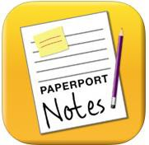 | - Take notes digitally on your iPad using this app  - Import and combine PDFs, PowerPoints, documents, images, web content and audio into your notes documents  - Includes tools for notetaking and marking up documents  - Record and replay audio recording of lectures  - Upload your notes to cloud storage services for easy access and sharing  - More Information: http://www.paperportnotes.com/
Cost: Free | Compatibility: iOS: iPad

iAnnotate
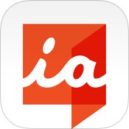 | - Annotate PDF, Word Doc, PowerPoint, and image files with this app  - Use the typewriter, pen, highlighter, stamp, note, underline, photo, voice and other tools to annotate your document  - Import PDFs or compress and export for secured sharing with others  - More Information: http://www.branchfire.com/iannotate/#leaveyourmark
Cost: Free – Android;  $9.99 - iOS | Compatibility: iOS: iPad; Android

Audiotorium
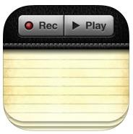 | - Record, type, review, organize and share your audio and text notes all in one app  - Organize your notes by Category and Subject  - Customize your notes with paper texture and fonts  - Integrate with TextExpander app to insert common phrases and other text with minimal key strokes  - More Information: http://app-apps.com/apps/audiotorium-notes/
Cost: $5.99 | Compatibility: iOS: iPad

Dictation/Speech-to-Text/Speech Recognition:

Dragon Dictation
- Speech recognition software that recognizes your works and transcribes them
- Dictate words into text messages, emails, social media, or paste into other apps and programs using the clipboard feature
- Hands free, quick dictation for anyone on the go
- More Information: http://www.nuance.com/for-individuals/mobile- applications/dragon-dictation/index.htm
Cost: monthly fee | Compatibility: iOS: iPad, iPhone, iPod Touch

Voice Typing in Google Chrome
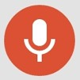 | - Go into your Tools menu in the Google Chrome Browser and select Voice Typing  - Click on the microphone that pops up and start talking  - Your text will be entered into the typing field  - Correct mistakes without moving your cursor  - No training needed  - More Information: https://goo.gl/bQfLtg
Cost: Free | Compatibility: Built-In Chrome Browser Option

VoiceNote
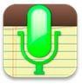 | - Extension for Google Chrome that allows you to type by simply speaking out loud  - Create a shortcut for easy use with other applications  - Speak your punctuation or click the buttons to add it to the text  - More Information: https://goo.gl/LVMywx
Cost: Free | Compatibility: Google Chrome Extension

Mind Mapping & Brainstorming:

Popplet
- Online and app based mind mapping too
- Visually put your thoughts down to create mind maps easily
- Print these mind maps for yourself or share with others
- More Information: http://popplet.com/
Cost: Free: web and lite  app, $4.99: full app | Compatibility: Online Resource; iOS: iPad, iPhone, iPod touch

MindMeister
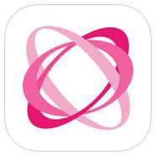 | - Mind Mapping/Brainstorming tool for use on personal devices and the web  - Collaborate in real time with other people  - Use the program to present your work  - Full use of software program and features costs a small, monthly fee  - More Information: http://www.mindmeister.com/
Cost: Free – up to 3 maps; $6.00/month additional maps and  features | Compatibility: Online Resource; iOS: iPhone, iPad, iPod touch; Android

Idea Sketch
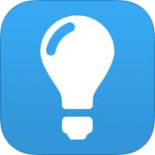 | - Draw and create mind maps, concept maps, and flow charts  - Convert your diagram into a text outline, or outline and turn it into a concept/mind map  - Use to brainstorm, illustrate concepts, make lists and outlines, plan presentation and create organizational charts  - Import text into Idea Sketch and automatically create diagrams and outlines  - Share your idea using email, Dropbox and other  - More Information: http://www.nosleep.net/
Cost: Free | Compatibility: Windows; Mac; iOS: iPad, iPhone, iPod touch; Windows Phone

Inspiration Maps
- Brainstorm and create mind maps using this app that’s similar to the fill Inspiration Program
- Organize projects to create flow charts
- Take notes using the visual system and icons to create maps and diagrams
- More Information: http://www.inspiration.com/inspmaps
Cost: $9.99 | Compatibility: iOS: iPad

Mindjet Maps
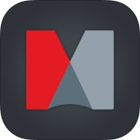 | - Create visual mind maps to organize brainstorm, concepts, tasks, ideas, lecture or meeting notes, or action items  - Easy to use gesture based commands  - Mapping features include text styling, relationship, and various other tools  - Integrate your maps to Dropbox for easy sharing  - More Information: https://www.mapsforthat.com/
Cost: Free | Compatibility: iOS: iPad; Android

Study Skills & Aids:

gFlash+ Flashcards & Tests
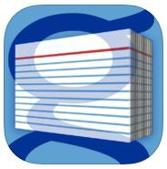 | - Use this flashcard system on-the-go to study any subject  - Create, download and manipulate flashcards while studying  - Different modes including Matching Game provide variation of learning methods  - Integrates with Google Docs – create spreadsheets of information and upload them to the app to make your study tools  - More Information: http://www.gwhizmobile.com/gWhiz/Home.php
Cost: Free; Pro - $3.99 | Compatibility: iOS: iPad, iPhone, iPod touch; Android

Shahi Visual Dictionary
- Online picture dictionary great for anyone, or those with a visual learning preference or English Language Learners
- Dictionary finds pictures from Flickr, Google and Yahoo
- Hyperlinked words in definition are easily able to be defined with pictures
- More Information: http://blachan.com/shahi/
Cost: Free | Compatibility: Online Resource

iAnnotate
- Annotate PDF, Word Doc, PowerPoint, and image files with this app
- Use the typewriter, pen, highlighter, stamp, note, underline, photo, voice and other tools to annotate your document
- Import PDFs or compress and export for secured sharing with others
- More Information: http://www.branchfire.com/iannotate/
Cost: Free – Android;  $9.99 - iOS | Compatibility: iOS: iPad; Android

Quizlet
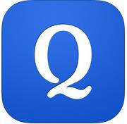 | - Online resource of study tools and game of virtually any educational subject  - 7 modes including traditional flash cards allow students to study in varied ways to help master material  - Generate your own content or use content other users have created  - More Information: http://quizlet.com/
Cost: Free | Compatibility: Online Resource; iOS: iPad, iPhone, iPod touch; Android

Study Blue
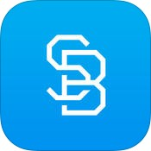 | - Study virtually any topic with this on-the-go flashcard study aid  - Create your own flash cards or use one of the over 150 million notes and cards already created by other uses  - Test yourself and get your score of how many right and wrong, with the option to focus more on the items you don’t know  - Study on the go using your mobile device  - More Information: http://www.studyblue.com/
Cost: Free | Compatibility: Web; iOS: iPad, iPhone, iPod touch; Android

Evernote Skitch
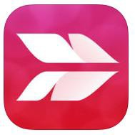 | - Using annotation and markup tools, make your point more easily with shapes, arrows and quick sketches  - Use on your desktop, tablet or phone  - Share your ideas and get your point across more clearly with ability to annotate  - Use annotation tools to collaborate and better study course materials  - More Information: https://evernote.com/skitch/
Cost: Free | Compatibility: Windows; Mac OS; iOS: iPad, iPhone, iPod touch; Android

iFlash
- Virtual flash-card program built specifically for Mac OS X with app for iOS devices
- Record audio, attach images, use categories to create custom cards
- Download decks of cards already created
- Study using your iOS device or print them out for studying on the go
- More Information: http://www.loopware.com/iflash/
Cost: $14.99 for iOS;  Touch app - Free | Compatibility: Mac OS X; iPad, iPhone, iPod touch

Organization & Task Management:

Todist
- Sub tasks, notifications, prioritization, reminders, notes, and filters in this all-in-one to-do list
- Access tasks from anywhere and collaborate on share tasks
- Streamlined, intuitive design
- More Information: https://en.todoist.com/
Cost: Free; premium  $29/year | Compatibility: Windows, Mac OS, Online Resource; iOS: iPad, iPhone, iPod touch; Android

MyStudyLife
- Create an account to keep track of your school work, assignments, course, schedule and exams
- Use the dashboard to schedule all your school related work
- Cross platform allows for access to your organizer wherever, whenever
- Set Reminders to help ensure all your work is done on time
- More Information: https://www.mystudylife.com/
Cost: Free | Compatibility: iOS; Android, Online Resource

Tile App
- Never lose your items with tile
- Connect your tile to your keys, bike, computer, or anything
- If you misplace your item, use the app to help you track the item down
- Tile will ring you to guide you to its location
- If tile is out of rang, the app will guide you to its last known location
- More Information: https://www.thetileapp.com/
Cost: ~$25 per tile, less per tile when buying in  multipacks | Compatibility: Standalone device with app compatibility; iOS; Android

Google Keep
- A visual bulletin board of post-it notes with reminders and tasks lists
- Ability to color code your notes, add reminders, and add photos and pictures to your notes
- Use your Google account to sync this on your computer, tablet and phone
- More Information: http://keep.google.com
Cost: Free | Compatibility: Online Resource; Android

RemindMe
- Set reminders of tasks while your browse the internet
- Use it to remind you of job tasks, meetings, online projects or tasks
- Sync the reminders with multiple computers so you get reminders at home, school or work
- Set reminders of “in” so long or “on” a certain time
- More Information: https://chrome.google.com/
Cost: Free | Compatibility: Chrome Extension

Priority Matrix
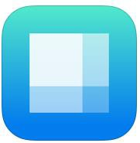 | - Simple interface task management app using methods of time management to help manage priorities  - Divide your tasks into one of four categories: Critical – Do Now; Critical but Not Urgent; Urgent but Can Be Delegated; Uncategorized  - App includes visual icons, email reports, master list of daily or weekly action items and more  - Ability to sync between devices and track your progress  - More Information: http://www.appfluence.com/
Cost: Free – basic;  $10/month Pro App | Compatibility: Windows; Mac; iOS: iPad, iPhone, iPod touch; Android

Remember the Milk
- Never forget the milk, or any other task using this task/to-do-list
- Organize your tasks with priorities, due date, time estimates, tags, repeating tasks and more
- Sync tasks on multiple devices and with calendars such as Gmail, Google Calendar, Outlook, iCal, and more!
- Get email, text or Instant Message Reminders to yourself using their website reminder feature
- More Information: http://www.rememberthemilk.com/
Cost: Free | Compatibility: Online Resource; iOS: iPad, iPhone, iPod touch; Android

Any.do
- Manage your life in a simple, clever, and fun way using this to-do list app
- Synch your tasks on your mobile device and computer or use the Chrome extension to sync with Gmail
- Use the reminder feature so you never forget what you need to do or where you need to be
- More Information: https://www.any.do/anydo
Cost: Free | Compatibility: iOS: iPad, iPhone, iPod touch; Android; Chrome Extension; Chrome App

myHomework
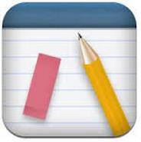 | - Track your homework, tests, projects, and lessons  - Set and receive reminders when assignments are due or tests are coming up  - Set up your class schedule within the app  - Synch your information with any of the available devices  - Integrates and works with Teachers.io  - More Information: https://myhomeworkapp.com/
Cost: Free | Compatibility: Windows; Chrome Extension; iOS: iPad, iPhone; Android; Kindle

iStudiez Pro
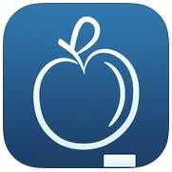 | - Stay organized and on top of all your school work and your schedule with this app  - Using the built-in planner with alerts and reminders, track tasks, homework, deadlines, meetings, and your grades  - Sync on all your devices so you’re never without this tool  - More Information: http://istudentpro.com/
Cost: $2.99; Window -  $9.99 | Compatibility: Mac; Windows; iOS: iPad, iPhone, iPod touch

Be S.M.A.R.T.
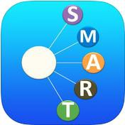 | - Set and achieve your goals using this app that employs the S.M.A.R.T. goal setting system  - Goal categories include: Career, Family, Health and Fitness, Knowledge and Skills and more  - Track your progress with reminders and visual achieved versus outstanding goals boxes  - More Information: http://www.goals4.me/
Cost: Free – 3 goals;  $1.99 for unlimited goals | Compatibility: iOS: iPad, iPhone, iPod touch

inClass
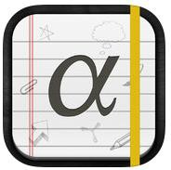 | - Keep track of all your courses and course tasks in one place  - Reminders of when tasks are due  - Take and share notes using text, videos, audio, or photo notes  - Collaborate with classmates using StudyRoom feature  - More Information: http://www.inclassapp.com/
Cost: Free | Compatibility: iOS: iPad, iPhone, iPod touch

Workflowy
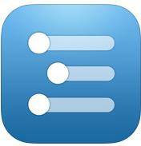 | - Organizational tool used to help manage to-do lists, collaborate on projects, take notes, and write research papers, journal, even plan and more!  - Free version allows for 500 items per month  - Nested layouts, lists, bullets, ability to add #dates and other format and layout options  - Sync between phone, tablet, and computer  - More Information: https://workflowy.com/
Cost: Free | Compatibility: Chrome Extension; iOS: iPad, iPhone, iPod touch

Time Management & Distraction Free:

Cold Turkey
- Block distracting websites
- Set the websites you want blocked and for how long and go “cold turkey” from them
- If the timer is still going, you won’t be able to access your blocked websites
- Pro version provides blocking of Applications, White Listing, Break Intervals, and Frozen Turkey features
- More Information: https://getcoldturkey.com/
Cost: Free for Basic,  $25 for Pro | Compatibility: Windows; Mac

SelfControl
- Block your own access to distracting websites, mail servers, or anything on the internet using this downloadable program to your computer
- Set a timer for the amount of time to block websites
- If the timer is still going, you won’t be able to view or access these websites
- More Information: https://selfcontrolapp.com/
Cost: Free | Compatibility: Mac OS

Time Timer
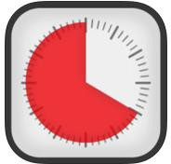 | - Visual timer great for people of any age  - Visually structure your time or break time up into segments using this timer program  - Easy to use app interface with up to four visual timers  - Time seconds, minutes or hours with this timer  - More Information: http://www.timetimer.com/
Cost: $.99-$4.99 | Compatibility: iOS: iPad, iPhone, iPod touch; Android

30/30
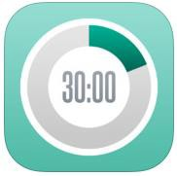 | - Create a task list and add a length of time to each task  - Start the timer and when it’s time to move on to the next task it will alert you  - Customize with colors, icons and labels  - More Information: http://3030.binaryhammer.com/
Cost: Free | Compatibility: iOS: iPad, iPhone, iPod touch

Tomato Timer
Tomato Timer | - Using the Pomodoro Time method, break up your work or school tasks into manageable worktimes  - Use the 25 minutes of worktime and 5 minutes of break time pattern to maximize workflow  - After a set number of short Pomodoros, take a longer Pomodoro break  - More Information: http://tomato-timer.com/
Cost: Free | Compatibility: Online Resource

focusbooster
- Pomodoro Timer to help you stay on task when completing work
- Using the Pomodoro Method of 25 minutes of work and 5 minute break, maximize your work session
- Track your time more efficiently within your account
- Productivity reports on your dashboard
- Different visual themes for your felxibility
- More Information: https://www.focusboosterapp.com/
Cost: Trial: free; Individual: $3/month;  Professional: $5/month | Compatibility: Online Resource; Windows; Mac

Strict Workflow
- Use this Chrome Extension to enforce a 25 minute work and 5 minute break distraction- free work zone
- Uses the Pomodoro Technique
- Blocks you from distracting websites you have set in your customizable list
- More Information: https://goo.gl/vMQqSI
Cost: Free | Compatibility: Chrome Extension

StayFocusd
- Increase your productivity by limiting the amount of time you spend on websites that waste your time
- Pre-program distracting and time wasting websites
- When your time limit is up, these sites will be inaccessible for the rest of the day
- More Information: http://goo.gl/I5OBeq
Cost: Free | Compatibility: Chrome Extension

MyTomatoes
- Use MyTomato to time and track your progress using the Pomodoro technique
- Start the timer and work for 25 minutes and then take a 5 minute break
- At the end of each work sitting, write what you did to track your progress
- More Information: http://mytomatoes.com/
Cost: Free | Compatibility: Online Resource

TimeTracker
- Track how long you’ve been off task in a website
- A running time clock appears at the top of the tab you have opened counting how many minutes and seconds you’ve been in that website
- More Information: http://goo.gl/uXKJgg

RescueTime Dashboard
- Personal-Analytic service to track how you spend your time on your computer, smartphone or tablet
- Get a customized report of what sites you visit and what you do on your devices
- No manual date-entry, it tracks as you work
- More Information: https://www.rescuetime.com/browser-plugin
Cost: Free | Compatibility: OS X, Windows, Linux, Android, ChromeOS

WriteRoom
- Full screen, distraction free writing environment
- Get your computer distractions out of the way with just you, and the text on your computer screen
- Limits layout ability, including limiting the ability to add graphs, and tables
- Auto save and word count are available features
- More Information: http://www.hogbaysoftware.com/products/writeroom
Cost: $9.99 | Compatibility: Mac OS
Dark Room
Dark Room | - Full screen, distraction free writing environment  - Similar to WriteRoom but for Windows computers  - Get your computer distractions out of the way with just you, and the text on your computer screen  - More Information: http://jjafuller.com/dark-room/
Cost: Free | Compatibility: Windows

Fokus
- Highlight only the text you want to read while Fokus dims and darkens the rest of your Chrome or Firefox window with an overlay
- Highlights the paragraph you’re reading with the ability to change the opacity of the background overlay
- Easy to install extension with the ability to turn the feature on or off
- More Information: http://goo.gl/pHjc3b or http://goo.gl/CZVhBw
Cost: Free | Compatibility: Chrome and Firefox Add-On

Stress Management and Relaxation:

Unstuck
- Put words to what you’re feeling – figure out what kind of “stuck” you have
- Using the app and website’s guided questions to lead you to figuring out what you are feeling and thinking
- Strategies provided at the end to help you overcome your “stuck” moment
- Create a free account to keep your stuck moments saved for reference later on
- More Information: https://www.unstuck.com/
Cost: Free | Compatibility: iOS: iPad, iPhone; Android, Online Resources

Breathing Zone
- Mindfulness in 5 minutes
- Using the app and follow along with the easy to follow breathing guide to lower breathing rate
- Five calming guide sounds with visual component
- Breathing Analyzer measures your breathing rate
- Timed sessions for breathing mindfulness
- More Information: http://www.breathing.zone/
Cost: $3.99 | Compatibility: iOS: iPad, iPhone; Android

Buddhify
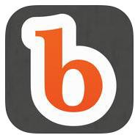 | - Increase your mindfulness and wellbeing with meditation on the go  - 11 hours of custom meditation for different parts of your day including travel, work, sleeping and more  - 5-30 minute sessions and solo meditation timer  - More Information: http://buddhify.com/
Cost: $4.99 – iOS;  $2.99 - Android | Compatibility: iOS: iPhone, iPad, iPod touch; Android

Momentum
- Get daily inspiration from your homepage
- Momentum provides a daily quote and picture to help your mood, motivation, and positivity
- Ability to add in a task list and customize the home screen for personalization
- Plus version has the ability to sync tasks with other common task management tools
- Plus version has additional customization features such as pictures, font, and colors
- More Information: https://momentumdash.com/
Cost: Basic Version: free; Plus Version:  $2.50/month | Compatibility: Chrome Extension

Guided Mind
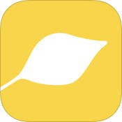 | - Relax and get guided through meditations on a variety of topics  - Step-by-step voice guided meditation  - Short (5 mins), medium (15 min) or long (30+ min) meditations  - Instrumental, nature soundscapes, with looping for continuous play  - Easy to use with instructions  - More Information: http://goo.gl/Q0JC0o
Cost: Free | Compatibility: iOS: iPhone, iPad, iPod touch

Research Tools:

Research Project Calculator
- Enter your assignment title, the start date, due date, the class, and pick the type of assignment is
- Choose from Writing Assignment or Essay, Oral Presentation with Slides, Video Assignment or History Day Research Notes
- Website will break down your assignment and give you a timeline for your project with deadlines for each step
- More Information: https://rpc.elm4you.org/
Cost: Free | Compatibility: Online Resource

Son of Citation Machine
- Use this tool to create citations, works cited, and bibliographies
- Formatting options for MLA, APA, Chicago and Turabian
- Fill in the web form with the information from your resource and click “Make Citation”
- Citation will show up on your screen to copy into you document
- More Information: http://citationmachine.net/index2.php
Cost: Free | Compatibility: Online Resource

Scrible
- Annotate, highlight and type right into your web browser
- Capture thoughts and share your comments in the web page
- Share your annotation with others via email or social media
- Bookmark and save your webpages in the cloud for access from anywhere
- More Information: http://www.scrible.com/
Cost: Free | Compatibility: Online Resource, iOS: iPad

Evernote Web Clipper
- With a single click, clip part of any webpage including images, text, or links
- Clippings get saved to your Evernote account for access later
- Collect research or items of interest in one place for easy organized information collection
- Read and access your research from any computer or device
- More Information: http://evernote.com/webclipper/
Cost: Free | Compatibility: Web add-on for Chrome, Firefox, Internet Explorer, Safari, and Opera

Sweet Search
- Search engine for students
- Provides trustworthy site search results from the most relevant, pre-evaluated and approved sites on the internet
- Find better information, faster from credible sources, such as primary sources while avoiding spam and marginal information sites
- More Information: http://www.sweetsearch.com/
Cost: Free | Compatibility: Online Resources

EasyBib
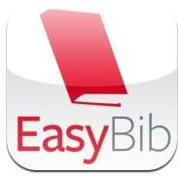 | - Free, Online Bibliography and Citation Generator  - Provides MLA, APA, and Chicago/Turabian citations for virtually any research source  - Manually input publication information for non-electronic sources or copy URL address into the website to create your citation  - More Information: http://www.easybib.com/
Cost: Free | Compatibility: Online Resource

BibMe
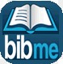 | - Online automatic bibliography maker on the web  - Search for the citation information or manually enter it into the site  - Add citations to your works cited list  - When your research is over, download your bibliography in one of four formats: MLA, APA, Chicago, or Turbian  - More Information: http://www.bibme.org/
Cost: Free | Compatibility: Online Resource

Pocket
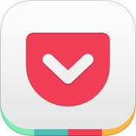 | - Save articles, videos, webpages, photos or anything you find online to read later using this app  - Content syncs across all devices for easy access, anywhere, anytime  - Simple, easy-to-use interface for great viewing  - Share your clippings with others  - More Information: https://getpocket.com/
Cost: Free | Compatibility: Mac; iOS: iPad, iPhone, iPod touch; Android; Kobo; Extension for Chrome,  Firefox, Internet Explorer, Safari; Windows Mobile; Kindle Fire

Pearltrees
- Organize, explore and share resources using this app
- Add files, web pages, photos and organize them according to project, assignment or collection
- Sync across computer, tablet and mobile device
- More Information: http://www.pearltrees.com/
Cost: Free | Compatibility: iOS: iPad, iPhone, iPod touch; Android; Extension for Chrome, Firefox, Internet  Explorer, Safari

Note Anywhere
- Add post-it notes to any of your web pages while researching
- Post-Its are saved so the next time you open the webpage, the post its will be there
- More Information: http://goo.gl/VDzeTS
Cost: Free | Compatibility: Chrome Extension

Vision:

AccessNote
- Notetaking tool for those who are Blind or Visually Impaired created by the American Federation of the Blind
- App combines notetaking capabilities with the other accessibility features and functions of the iOS device
- Input notes with either QWERTY Keyboard, refreshable Braille Display
- More Information: http://goo.gl/bozjm7
Cost: Free | Compatibility: iOS: iPad, iPhone, iPod touch

TapTapSee
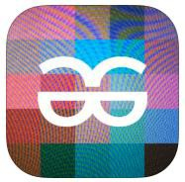 | - Use this app to help identify everyday objects for anyone with a visual impairment or who is blind  - Double tap the screen, take a picture of the object, and hear what the object is spoken out loud  - Turn VoiceOver on to have the object description read out loud  - More Information: http://www.taptapseeapp.com/
Cost: Free | Compatibility: iOS: iPad, iPhone, iPod touch; Android

LookTel Recognizer
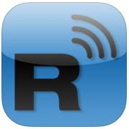 | - LookTel Recognizer allows users who are blind or low vision to recognize objects  - Build a library of images of objects commonly found in your daily life  - Once the library is built, place object in front of camera of phone and instant recognition and description of the object will occur  - More Information: http://www.looktel.com/recognizer
Cost: $9.99 | Compatibility: iOS: iPad, iPhone, iPod touch

LookTel Money Reader
- LookTel Money Recognizer allows users who are blind or low vision to recognize currency and will speak the denomination out loud
- Place money under the camera of your phone and the app will recognize the currency amount
- Over twenty currencies supported by this app
- More Information: http://www.looktel.com/moneyreader
Cost: $9.99 | Compatibility: Mac; iOS: iPad, iPhone, iPod touch

Be My Eyes
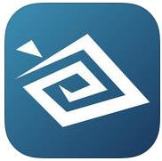 | - App that connect people who are blind with sighted volunteers around the world  - Using video chat, volunteers help people who are blind with a variety of tasks as they serve as the person who is blind’s eyes  - A network of thousands of both blind and sighted people across the world  - More Information: http://www.bemyeyes.org/
Cost: Free | Compatibility: iOS: iPad, iPhone, iPod touch

NVDA Screen Reader
- NonVisual Desktop Access (NVDA) is a free, open source screen reader built for Windows based operating system computers
- Download to your computer directly or to a USB drive and run on any computer without installation
- Works with many popular applications such as web browsers, email, and Microsoft Office programs
- Ability to convert text into a Braille using Refreshable Braille Display
- More Information: http://www.nvaccess.org/
Cost: Free | Compatibility: Windows

DanKan: Colorblind Fix (iOS)/DanKam A2.0+ (Android)
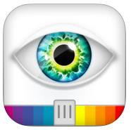 | - Use this app to help differentiate between colors more easily for people who are color blind or have trouble distinguishing colors  - Take a picture of the object you want to remix and use the modes to adjust the colors and hues to make it easier to differentiate color(s) the object actually is  - Helps enhance the colors individuals who are color blind see but this does not mitigate all functional limitations of color blindness  - More Information: https://itunes.apple.com/dankam-colorblind-fix
Cost: $2.99 | Compatibility: iOS: iPad, iPhone, iPod touch; Android

Vision Assist
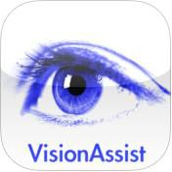 | - Use your iDevice to become an instant handheld magnifier or CCTV  - Zoom images up to 20x  - Change display mode to match your best vision including black and white, color, highlights, contrasting colors, and smart text to enhance text  - Magnify documents, books, whiteboard or anything you see  - Compatible with VoiceOver  - More Information: http://visionassist.slinkyware.com/
Cost: $5.99 | Compatibility: iOS: iPad, iPhone, iPod touch

NaviDys
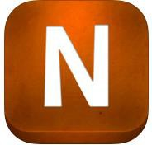 | - Adapt and adjust webpages to your own reading preference settings  - Adjust the font to one of 10 available fonts including Dyslexie font  - Adjust font size, letter spacing and line spacing of the webpage you’re reading  - More Information: http://michaeldardol.com/navidys/
Cost: $2.99 | Compatibility: iOS: iPad

ER Browser
- Adapt and adjust webpages to your own reading preference settings
- Choose your font from options such as OpenDyslexic
- Customize the background color of the webpage to decrease visual stress and improve reading ability
- Adjust font size and letter spacing
- Bookmark your favorite websites or search your stored history
- More Information: http://erbrowser.com/
Cost: $0.99 | Compatibility: iOS: iPad, iPhone; iPod touch

Thunder Screen Reader
- Free screen reader for Windows based computers that provides access for individuals who are blind or low vision
- Download to your Windows computer or download to a USB drive to run from any computer without the need to download
- Use this program to access internet browsers, word processing and common applications on your computer in multiple languages
- More Information: http://screenreader.net/index.php?pageid=11
Cost: Free | Compatibility: Windows

Fleksy
- Increase your keyboard or text input system size to 114% the normal size increase ease of sight using this QWERTY keyboard
- State-of-the-art system powerful enough for individuals who are blind or low vision to use by not needing to look at the screen to type
- Powerful word prediction system and autocorrect system edits your text without the need to even see the keyboard
- More Information: http://fleksy.com/
Cost: $.99 | Compatibility: iOS: iPad, iPhone, iPod touch; Android

Turn Off the Lights
- Click the light bulb button to get your screen to fade to a dark opacity overlay
- Everything but the key area you are working in, such as a YouTube Video, a Google Doc, or an HTML 5 website will fade
- Ability to adjust opacity and darkness
- Shortcut keys to command program
- More Information: http://goo.gl/l96MtE
Cost: Free | Compatibility: Chrome Add-On

Fokus
- Highlight only the text you want to read while Fokus dims and darkens the rest of your Chrome or Firefox window with an overlay
- Highlights the paragraph you’re reading with the ability to change the opacity of the background overlay
- Easy to install extension with the ability to turn the feature on or off
- More Information: http://goo.gl/pHjc3b or http://goo.gl/CZVhBw
Cost: Free | Compatibility: Chrome and Firefox Add-On

SAS Graphic Accelerator- Chrome plugin used for interactive audio description of visual maps, graphs and charts
http://documentation.sas.com/?docsetId=gracclug&docsetTarget=p1jh9c90yjh9ien1vxphkd7odrp6.htm&docsetVersion=1.0&locale=en

Hearing & Auditory Support:

Ava
- On-the-fly closed captioning for what is being said around the user 24/7
- Use the app in meetings or conversations to see what people are said
- Large font and user friendly font on the screen for easy reading
- Basic Version: Caption one-on-one conversations or group conversations for 2 or more people for up to 5 hours per moth
- Unlimited Version: Caption one-on-one conversations or group conversations for 2 or more people for unlimited hours per month
- More Information: ava.me
Cost: Basic: free; Unlimited:  $29.99/month | Compatibility: iOS: iPad, iPhone; Android

soundAMP R
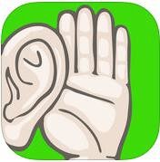 | - Amplify sounds and the world around you with this app built for anyone with hearing loss  - Sounds comes in through your iDevice microphone and is played back in real time through earbuds connected to your device  - Ability to customize and control sound for each ear individually along with the ability to adjust the volume, background sound level and tone  - Record lectures, meetings and appointments with the ability to listen back later on the device or by exporting to your computer  - More Information: http://goo.gl/lw6p3r
Cost: $4.99; lite  version: $0.99 | Compatibility: iOS: iPad, iPhone, iPod touch

Sign 4 Me – A Signed English Translator
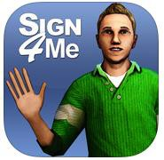 | - Learn sign language using this app with over 11,500 words  - 3D avatar characters can be zoomed in or out or rotated to give you the best viewing of every sign  - Type in a sentence, phrase, word or alphabet for visual playback with the Signed English translation  - May not provide correct grammatical structure of signed sentences  - More Information: http://www.signingapp.com/sign4me_desktop.html
Cost: $9.99 | Compatibility: iOS: iPad, iPhone, iPod touch

Communication:

Hidden Curriculum for Adolescents and Adults
- Learn how to deal with the unstated customs and rules all of us encounter on a daily basis
- Using real life examples, this app address the ever-elusive “hidden curriculum” we’re surrounded by daily
- Topics include: social relationships, community, money matters, workplace, and more
- More Information: https://itunes.apple.com/hidden-curriculum
Cost: $1.99 | Compatibility: iOS: iPad, iPhone, iPod touch

Verbally
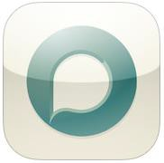 | - Augmented communication app for individuals of different ages and abilities  - Simplistically designed interface for ease of use  - With over 50 essentials words, a Core Phrases Grid for common phrases and Text Prediction to increase speed of communication  - Option to upgrade to Verbally Premium for ability to customize phrases  - More Information: http://verballyapp.com/
Cost: Free | Compatibility: iOS: iPad

Built-In Accessibility:

Windows
- Personalize your Windows Computer with any of the build-in Accessibility Features to support ease with seeing, hearing, and mobility interactions with computer
- Features Available Are: Screen Reader/Text-to-Speech (Narrator), Magnification (Magnifier), Keys Commands (Mouse Keys), Speech-to-Text and Voice Control (Speech Recognition), Visual Notification to replace sounds, Keyboard on Screen, Toggle Keys, Adjustable Mouse Settings, High Contrast Schemes, and Ability to Personalize the Appearance of the Computer including text
- Tutorial Videos Available on the websites below
- List of All Features with Comparison Chart: http://www.microsoft.com/enable/products/chartwindows.aspx
- More Information: http://www.microsoft.com/enable/default.aspx
Cost: Free | Compatibility: Windows

Mac
- Personalize your Mac Computer with any of the build-in Accessibility Features to support ease with seeing, hearing, and physical/mobility, literacy interactions with computer
- Features include: Text-to-Speech (VoiceOver), Zoom, High Contrast, Sticky Keys, Speech-to-Text and Voice Control (Speech Recognition), Word Completion (Word Prediction), and more!
- More Information: http://www.apple.com/accessibility/osx/

