**Scheduling an Appointment**

CUNY LEADS Plus Office – Room D211

Tel. 718-368-6639

[Steve.Alexander@kbcc.cuny.edu](mailto:Steve.Alexander@kbcc.cuny.edu)

**Office Hours: By Appointment**

Kingsborough Community College

2001 Oriential Boulevard

Brooklyn, NY 11235



**LEADS Plus Central Administration**

Barbara Bookman, University Director, Disability Programs

**Job Developers**

Kristopher Robinson – Neurodiverse

Bethany LaLonde – Staten Island

Trivis Laurore – Brooklyn

Cruz Marina Esquilin – Bronx

Molly Pearl – Manhattan & Veterans

Kate Wong – Queens



[www.facebook.com/kingsborough.leads](http://www.facebook.com/kingsborough.leads)

 

**CUNY LEADS Plus Advisors**

**Kingsborough Community College**

Steve Aexander, Jr.

**Bronx Community College**

William Medina

**Guttman Community College/SPS**

Marta Orellana

**Queensborough Community College**

Mark Mueller

**College of Staten Island**

Lisette Munoz



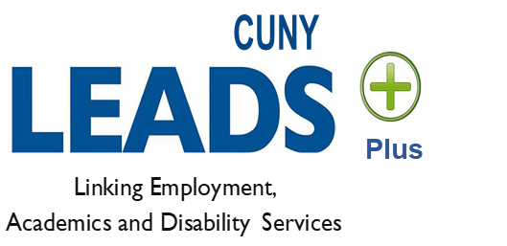

# Kingsborough Community College CUNY LEADS

**Steve Alexander, Jr., LMHC**

*LEADS Plus Counselor*

**LEADS Office, Room D211**

Tel. 718-368-6639

Fax:718-368-4782

[Steve.Alexander@kbcc.cuny.edu](mailto:Steve.Alexander@kbcc.cuny.edu)

**What is the LEADS Plus Program?**

CUNY LEADS Plus is a new program for neuro-diverse CUNY students with unique abilities. The program offers enhanced individual and group services that helps you transition to college, promotes academic success, and grooms you for realistic employment.

LEADS Plus is only available on five select CUNY campuses. Each campus has a LEADS Plus advisor that collaborates with campus departments, agencies and businesses to provide career guidance and support to students.

This exciting program is FREE for all eligible CUNY students.

__________________________________

**Services**

• Covers Books and Transportation if not provided by ACCES-VR for up to three years

• Academic Advisement and Assistance with Transitioning to College

• Professional and Student Success Skills Workshops

• Career Assessment Services and Work-Readiness Skills

• Built-in Internship and Additional Internship Exploration

• Assistive Technology Services

• Job Search Skills and Assistance including: Resume and Cover Letter Review and Editing, Mock Interviewing, Interview Follow Up, and Soft Skills Training

• Career Counseling

• Self-Advocacy Skills 

• Referrals for Tutoring, Scholastic and Health Service Supports, Benefits & Entitlements

**Eligibility**

• Any CUNY students who are enrolled in a CUNY program and are on the autism spectrum, have learning disabilities, or psychological disabilities and are sponsored by ACCES-VR.

**\*** The student must present documentation of disability to the LEADS Plus Advisor. **All documents & information will be kept confidential.**

__________________________________

**Student Responsibility**

* Students must submit medical, educational or psychological documentation regarding their disability
* Students are responsible for completing the appropriate documentation to determine eligibility for the program as provided by the LEADS Plus Advisor
* Students should be prepared to explore realistic and rewarding career goals
* Students must meet with the advisor on an ongoing basis.

__________________________________

**Resources**

LEADS Plus partners with the following KCC offices to promote students success:

**LEADS Office**

Room D-222, 718-368-5161

**Access-Ability Services**

Room D-205, 718-368-5175

[www.kbcc.cuny.edu/access-ability](http://www.kbcc.cuny.edu/access-ability)

**Career Development, Transfer, New Start & Internship Opportunities**

Room C-102, 718-368-5115

www.kbcc.cuny.edu/career

**Counseling & Health Services**

Room D-102, 718-368-5975

www.kbcc.cuny.edu/CounselingServices

**Single Stop**

Room V231, 718-368-5411

[www.kbcc.cuny.edu/singlestop](http://www.kbcc.cuny.edu/singlestop)

**TRiO Student Support Services**

Room D205, 718-368-5175

www.kbcc.cuny.edu/TRio

__________________________________

**Partnership with NYSED Office of ACCES-VR**

55 Hanson Place, 2nd Floor

Brooklyn, NY 11217

<http://www.acces.nysed.gov/vr/brooklyn-district-office> 718-722-6700